PROPEL 101:

Investigating Molecular Mechanisms
Adrianna Dabrowska, PhD
December 4th 2025

How to read a paper?
- Not about memorizing/learning ALL the different mutations, etc.
- Read the abstract, read the figures -> what is the paper trying to present
- Then do a deep dive -> The introduction should explain the previous work and why this is important for the field – if it is very novel you can check additional short reviews
- Pick a couple of sections that sound most interesting and do a deep dive into those.
- Think about why they performed these experiments, have they explained everything?
- What is the key message

How to understand and convey information?
From the perspective of a journal club:
- What is the key message?
- What are the main findings? (you don’t have to show all the figures
and all the supplementary figures)
- What is innovative about it?
- Is there anything that remains unanswered?
- What is the impact of this publication on a larger scale (let’s say
cancer field).

Why do we perform research?
- To understand ->
- basic biology (how things work),
- to discover underlying mechanisms,
- to be able to advance science,
- cure diseases

What is a disease?

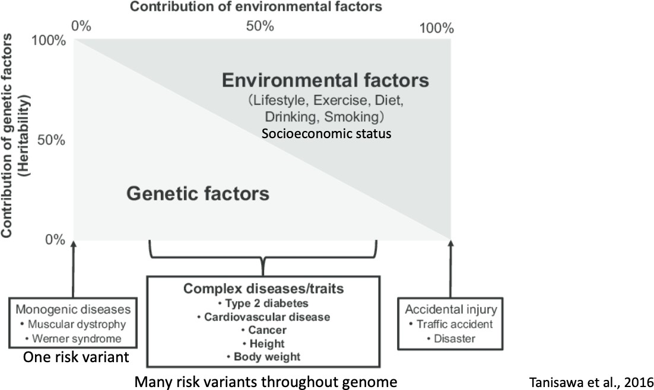

What is a molecular mechanism?
A molecular mechanism describes the detailed, step-by-step sequence of events that occurs at the molecular level to carry out a biological process.
  - Molecular mechanisms are the processes that explain how genetic variations lead to observable disease phenotypes. They also refer to the underlying processes that contribute to cell and organismal physiology

The molecular processes that underlie the pathogenesis of diseases
  - Alterations in mRNA translation or protein stability that affect a phenotype
- Sickle Cell Anemia: Normal: Gene makes correct hemoglobin → round red blood cells → good oxygen delivery Mechanism disrupted: One letter change in gene → abnormal hemoglobin → sickle-shaped cells → poor oxygen delivery
- Insulin and Diabetes: Healthy mechanism: Insulin gene → proper insulin → glucose enters cells Type 1 Diabetes mechanism: Immune system attacks insulin-producing cells → no insulin → high blood sugar

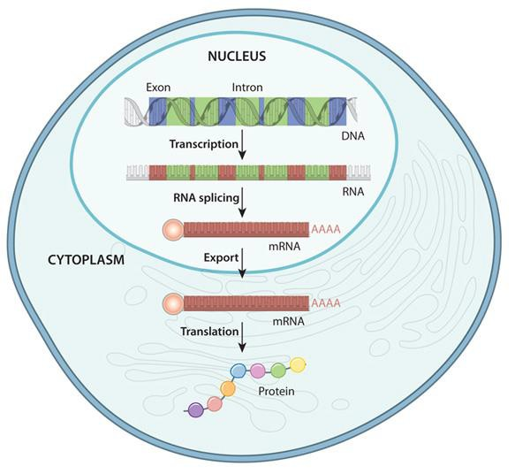
Gene expression pathway - Central Dogma

Nature Education, 2010

Transcription -> DNA into RNA

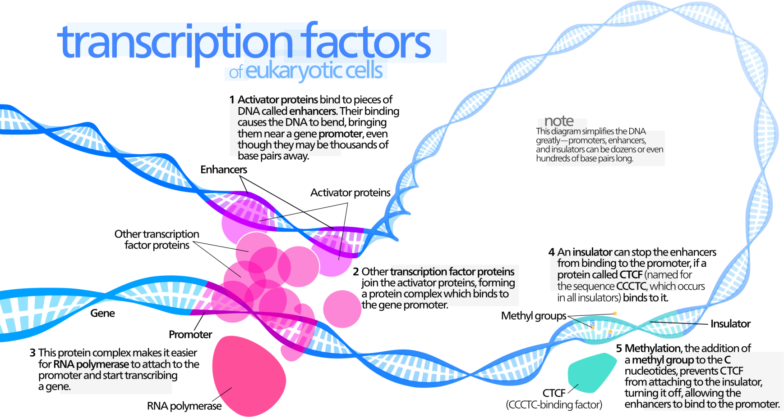

Wikimedia Commons

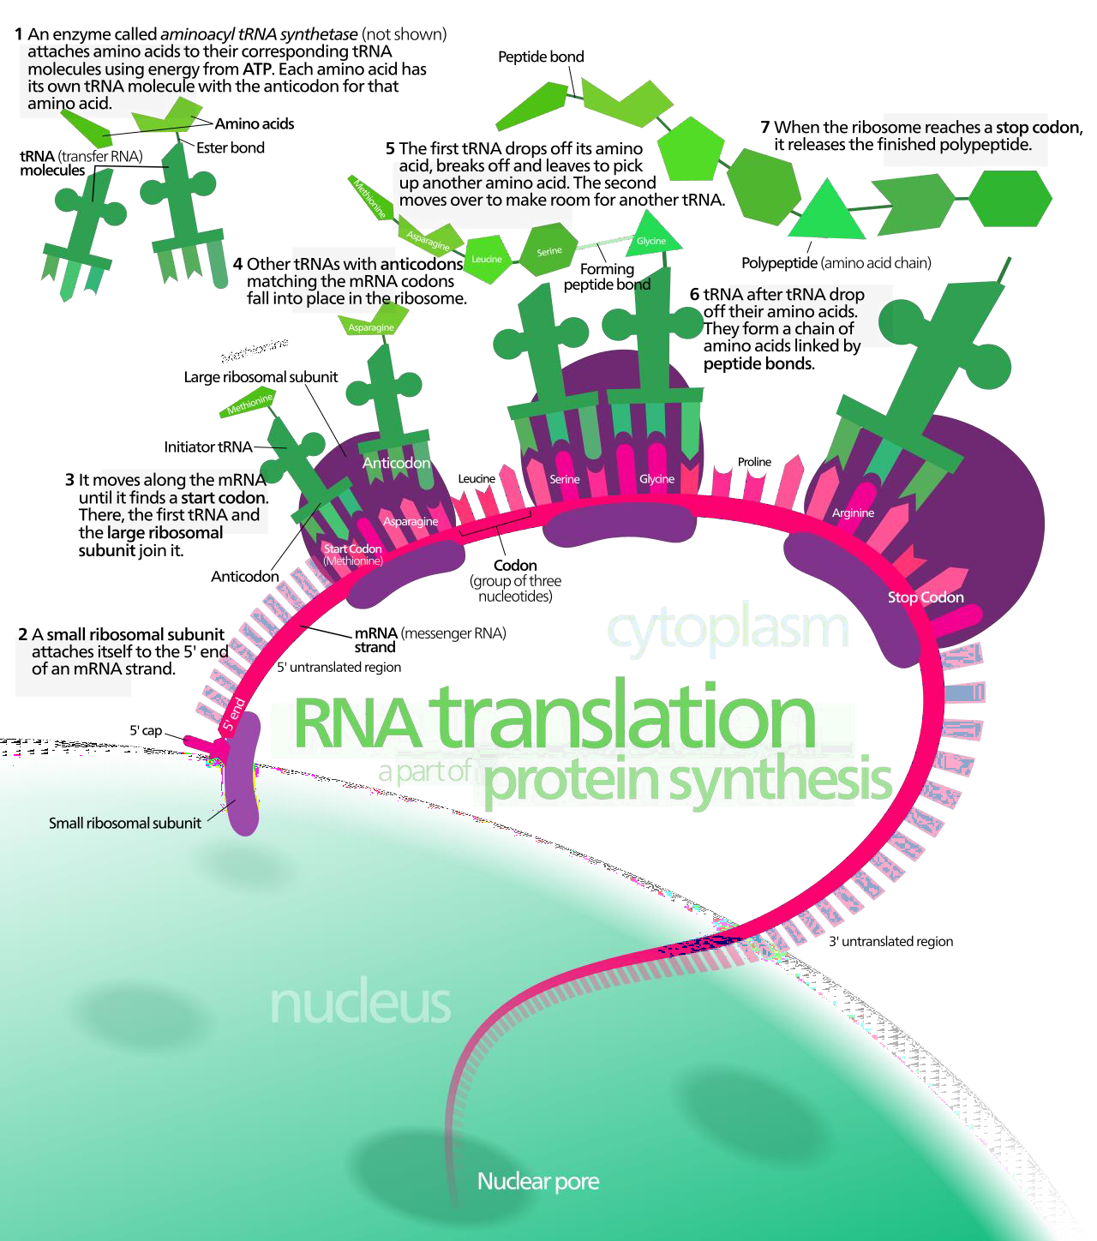
Translation –> mRNA into protein

Wikimedia Commons

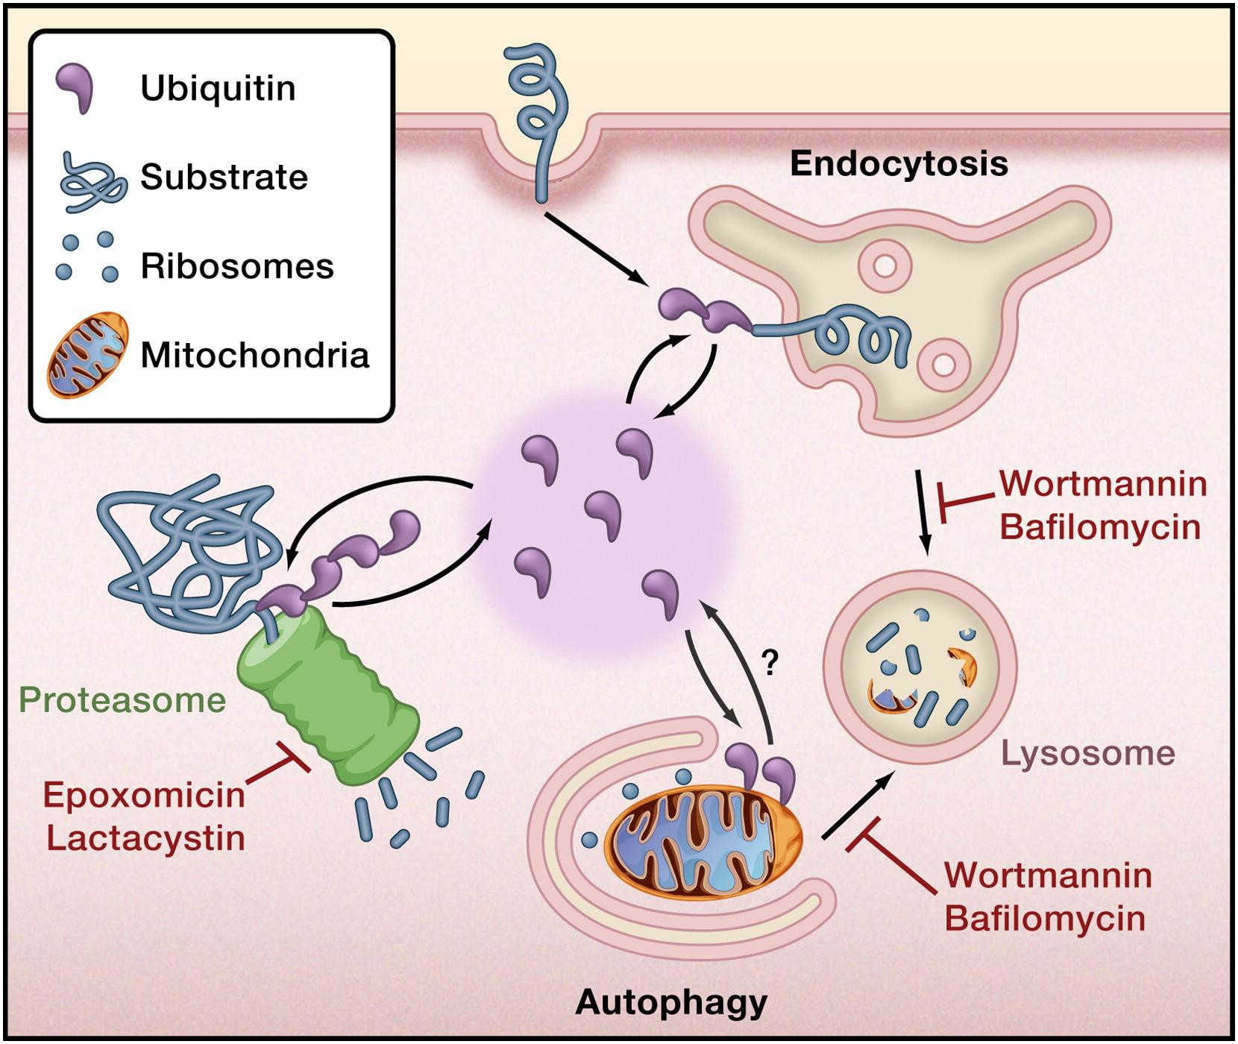
Protein turnover

Clague MJ, Urbe S, Cell Minireview, 2010

DNA damage

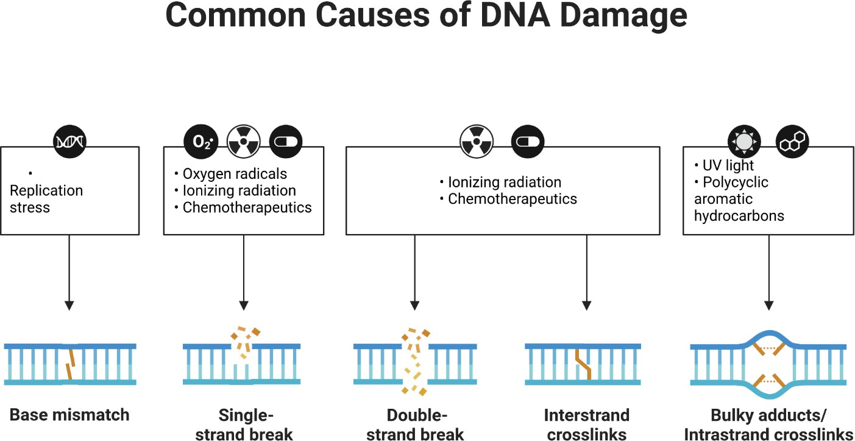

p53 (gene TP53)
- ”guardian of the genome”
- Activated by DNA damage
- Transcription factor
- Induces cell cycle arrest, allowing damage repair or inducing apoptosis
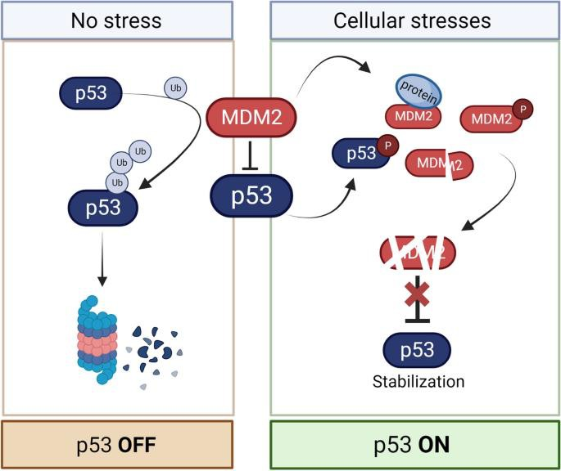

Marques JF, Kops GJPL, Chromosome Res, 2023

DNA damage – cancer treatments
  - Many cancers = TP53 mutated
  - Yet DNA-damaging chemotherapies still induce apoptosis
→ There must be alternative pathways

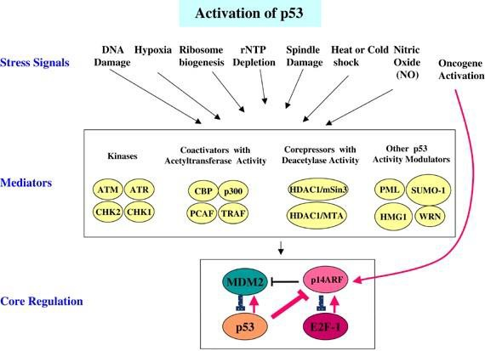
Harris SL, Levine AJ, Oncogene, 2005

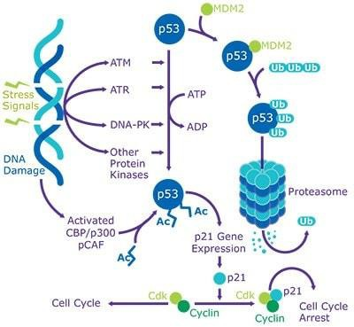
p53 – dependent apoptosis

Sigma Millipore

p53 – independent apoptosis
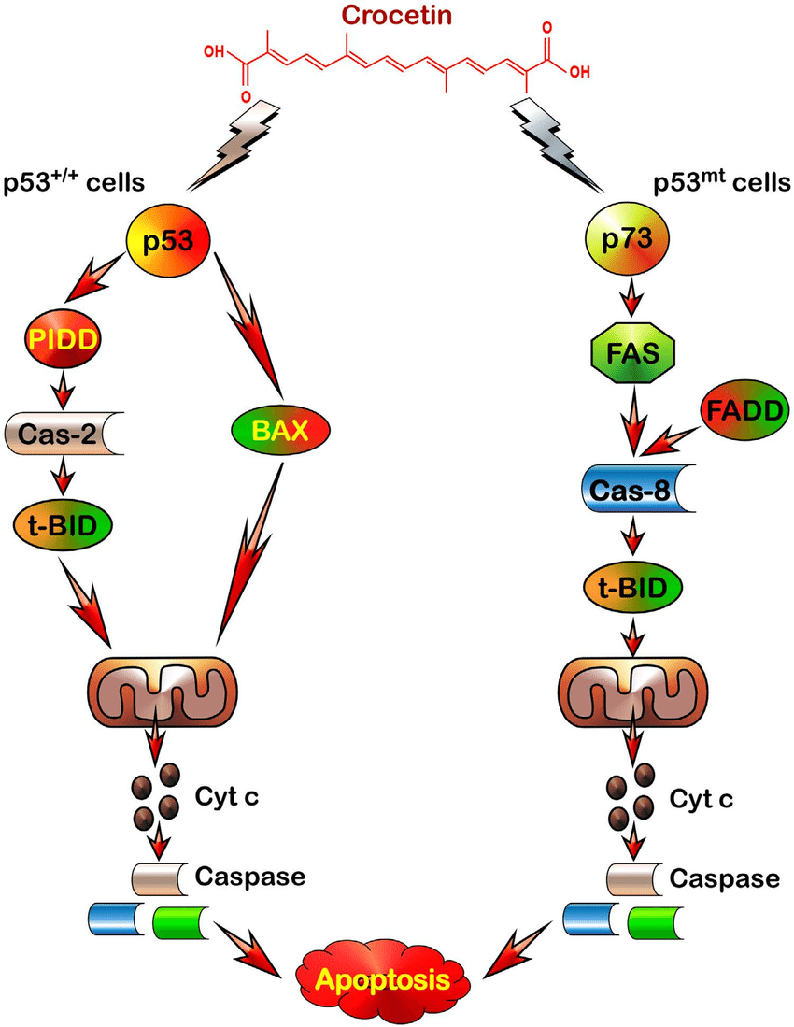
Ray P, Scientific Reports, 2016

Apoptosis
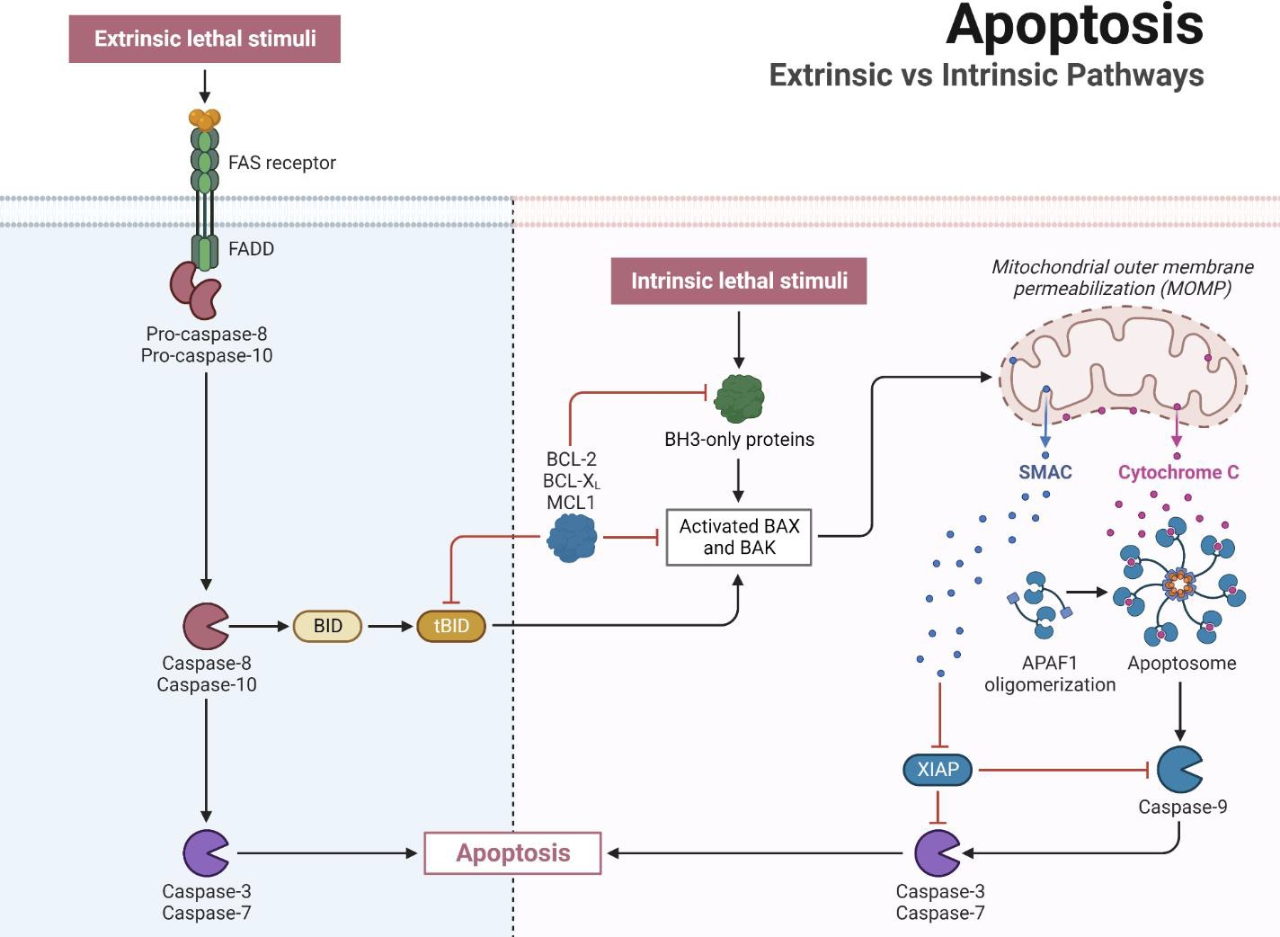

Stages of
Apoptosis
in Cancer Cells

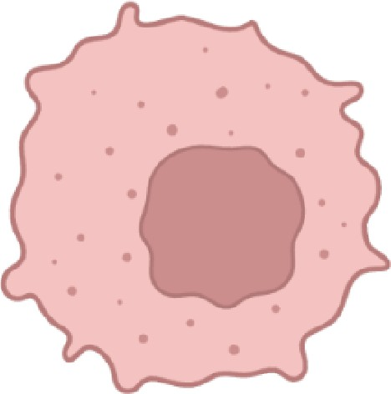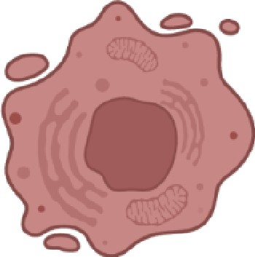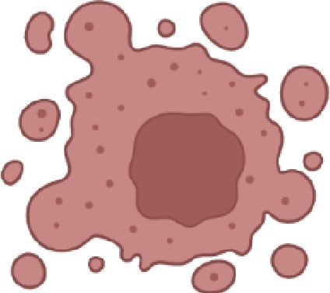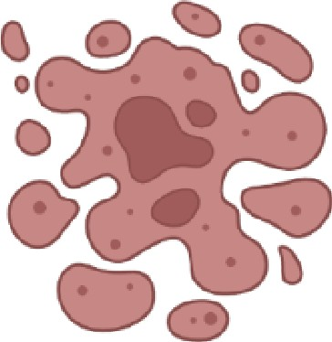

Stage 1

Non-apoptotic cancer cell
Stage 2

Cell shrinkage and chromatin condensation
Stage 3

Nuclear fragmentation and membrane blebbing
Stage 4

Apoptotic body formation

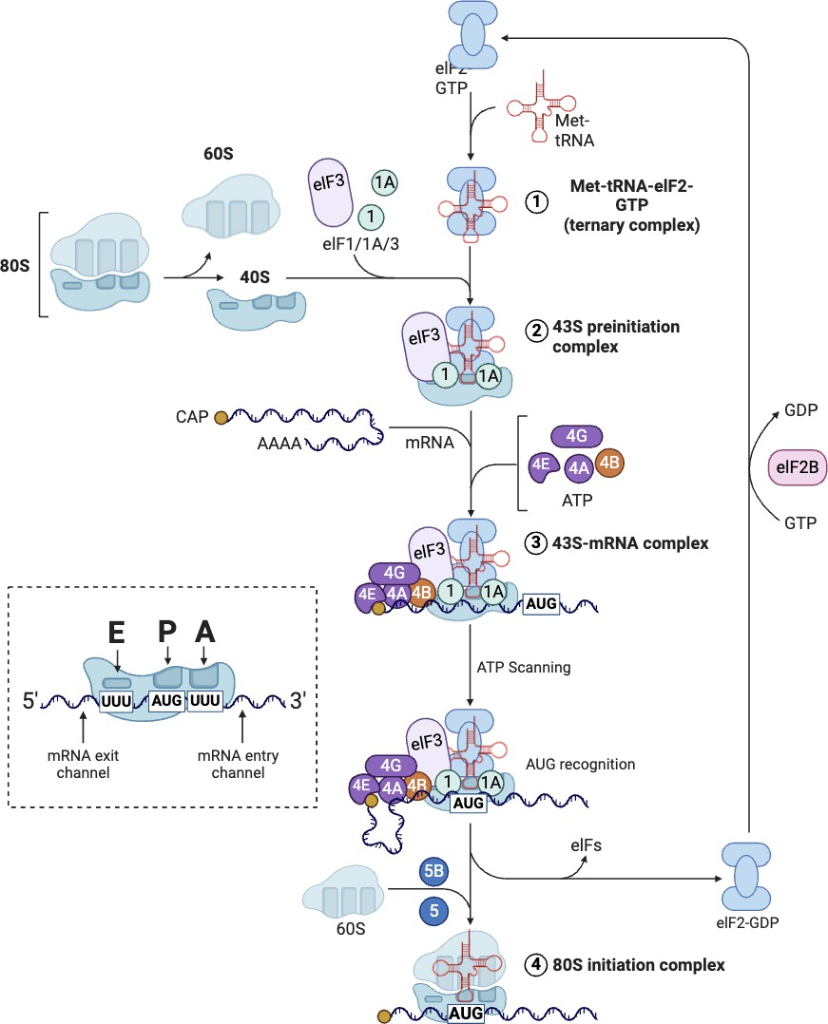
mRNA translation

Ribosome stalling

- Ribosome pauses at a codon it cannot decode
- Causes ribotoxic stress
- Can activate
downstream signaling pathways

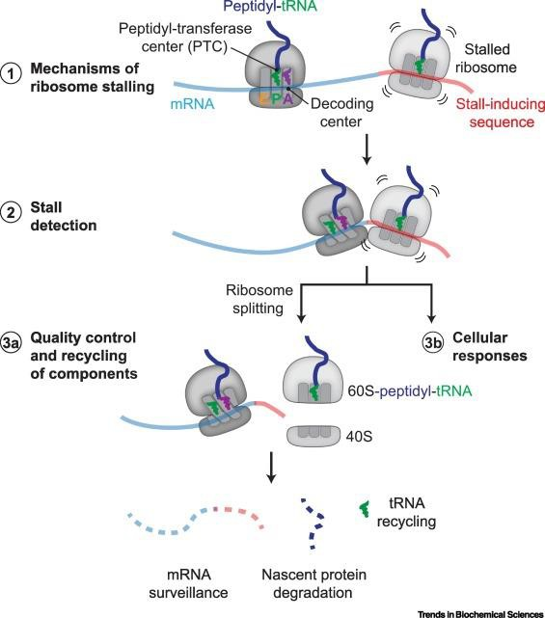

Yip MCJ, Shao S, Trends in Biochemical Sciences, 2021

Ribosome stalling

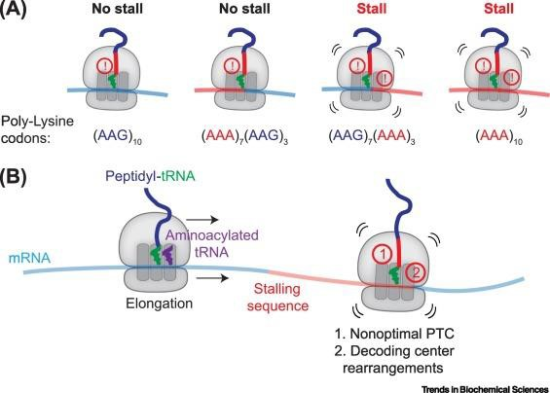

Yip MCJ, Shao S, Trends in Biochemical Sciences, 2021

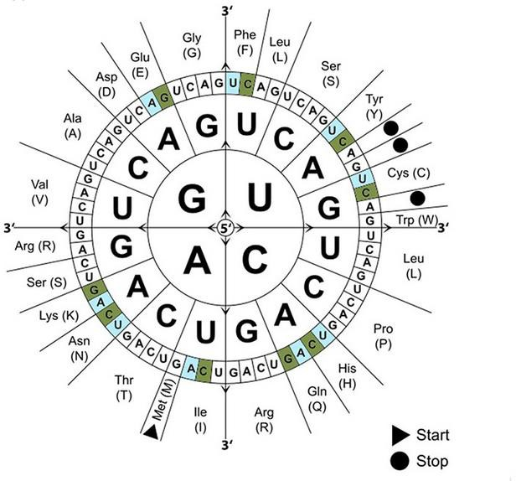
Codon usage

- Common codons
= abundant tRNA
- Rare codons (e.g.,
UUA) = low tRNA
- Missing tRNA →
ribosome stalls

Methods

Methods to measure translation
  - Puromycin incorporation:
Puromycin is an antibiotic that prevents protein synthesis by binding to the C-terminus of nascent peptide chains. This causes premature chain termination, releasing the polypeptide chain

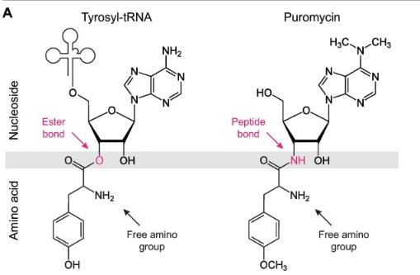
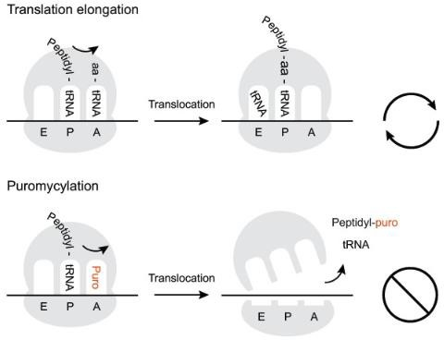
- Low puromycin = low translation
Aviner R, Computational and Structural Biotechnology Journal, 2020

Methods to measure translation efficiency

RNA-seq -> total RNA from the cells -> transcriptional changes

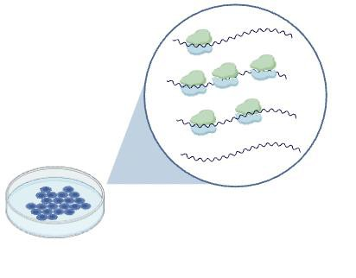
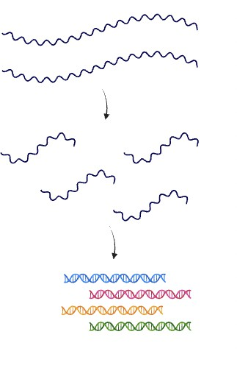

Methods to measure translation efficiency

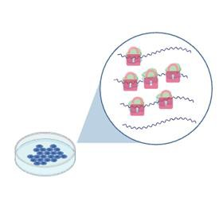
Polysome profiling -> translational efficiency changes -> high polysomal fractions over free mRNA / low translated
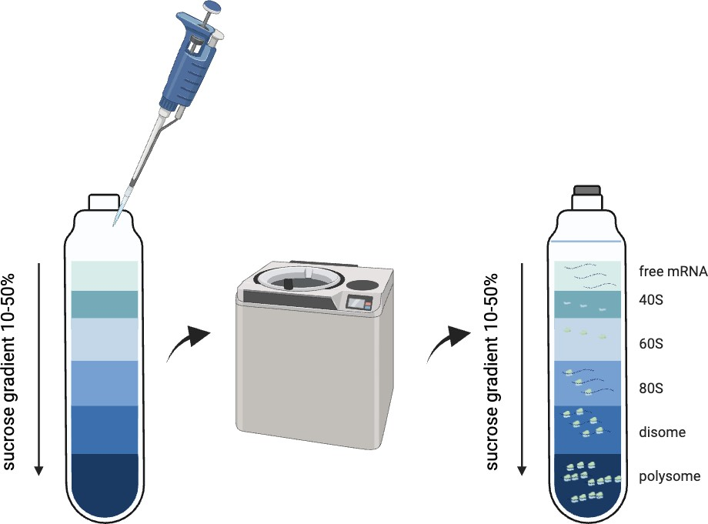

Methods to measure translation efficiency

Polysome profiling -> translational efficiency changes -> high polysomal fractions over free mRNA / low translated

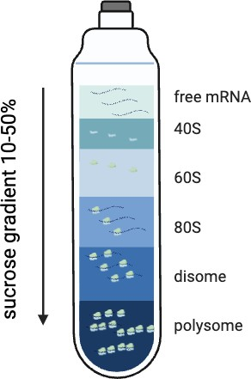
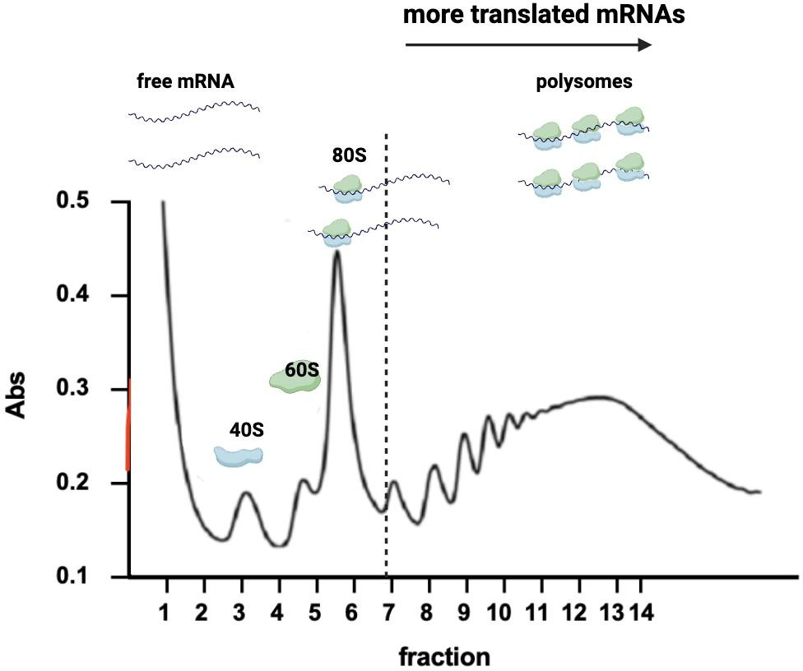
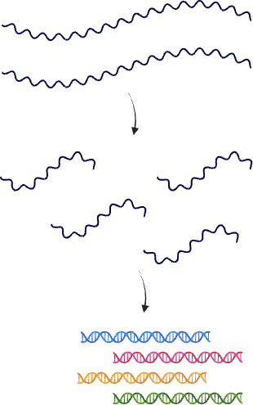

Methods to measure translation efficiency

Ribosomal profiling (ribo-seq) -> translational efficiency changes and positional information about the ribosome

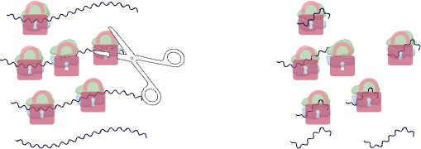

Methods to measure translation efficiency

Ribosomal profiling (ribo-seq) -> translational efficiency changes and positional information about the ribosome
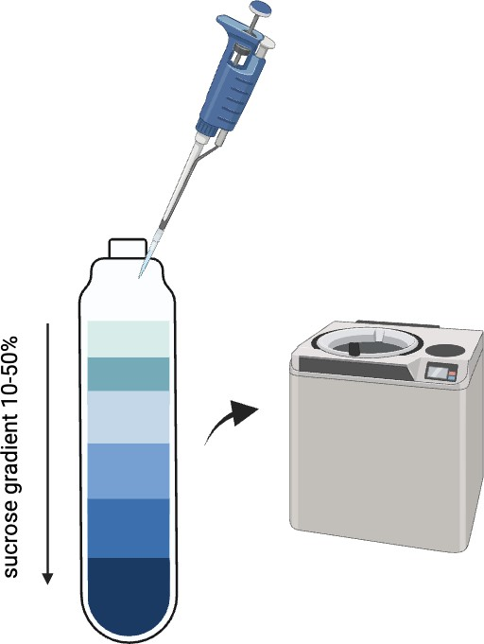
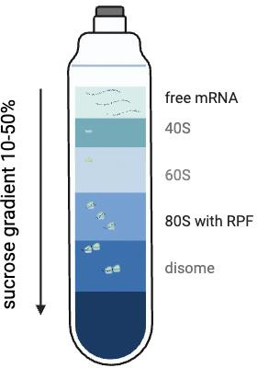

Methods to measure translation efficiency

Ribosomal profiling (ribo-seq) -> translational efficiency changes and positional information about the ribosome

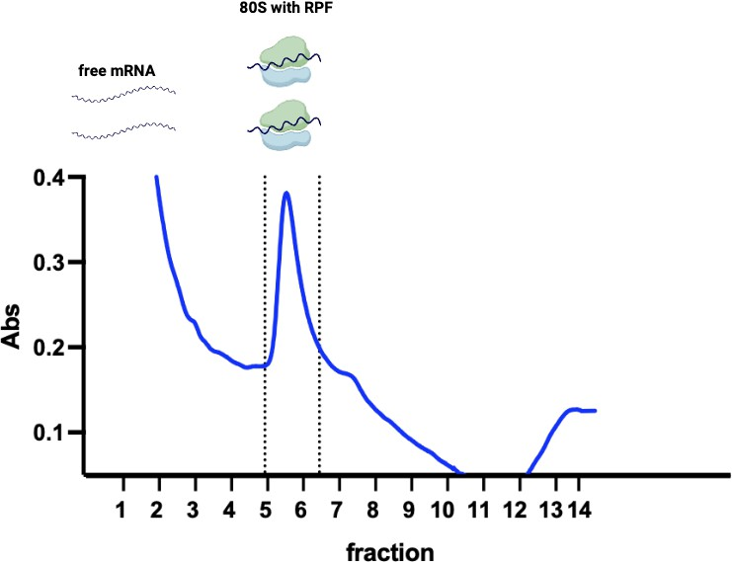
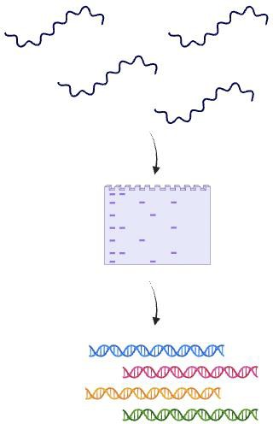

Combined with RNA-seq to adjust translational changes for transcriptional changes


Flow cytometry


Fllo,w cytometer CBD LSIR, with pi<ONE)
I

!!=ION
cytomet,
BID ILSR 11)

Flow
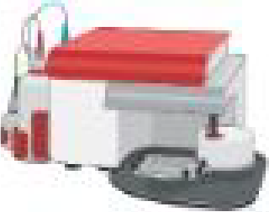
cytom ter
(BD Accurl C6}

!Flo .. cytorrieter (BD·FACSLyrl c:)

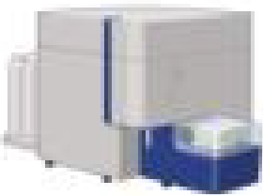
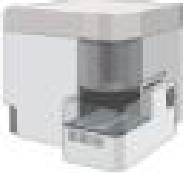
Aun.oma-tic mlcro-sam Hng s .stem (Cyt 'k Aurora.·

Flow cytomeitcy (MACSOuant an lyrer)

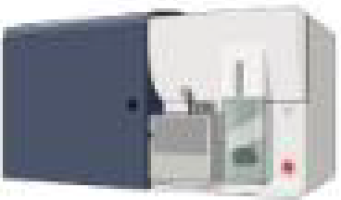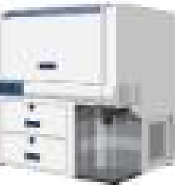

Cell sorter
(BO FACSAria II)
Cell n lyzer

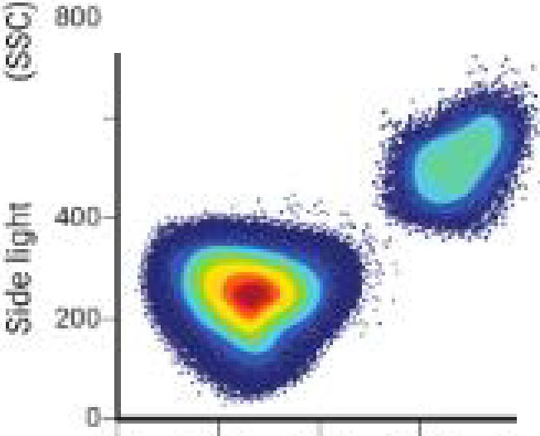
(BD FACSym phony.)
100
16011
[llj
I
Flow
c:)!'tornetry

A._.
( l
Poputation • Other
of interest c@ Is




Flow cytomet111

Test

Fiow
0 2(10 .IIOIJ �00 llOO H)O□
orwan:I bght s-catter (FSC)

(lntellicyt iQ;
s�re ner)
u1be
cytometry Cell so:rting low,c:ytometry gr p

Flow cytometry

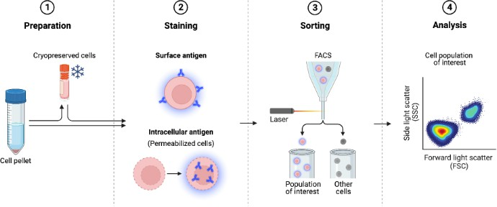

CRISPR

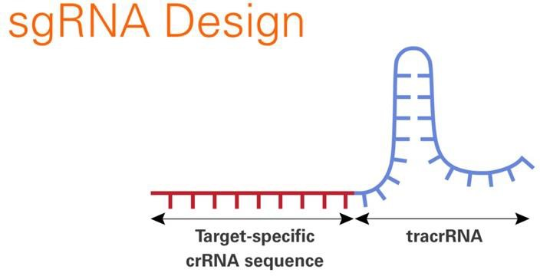

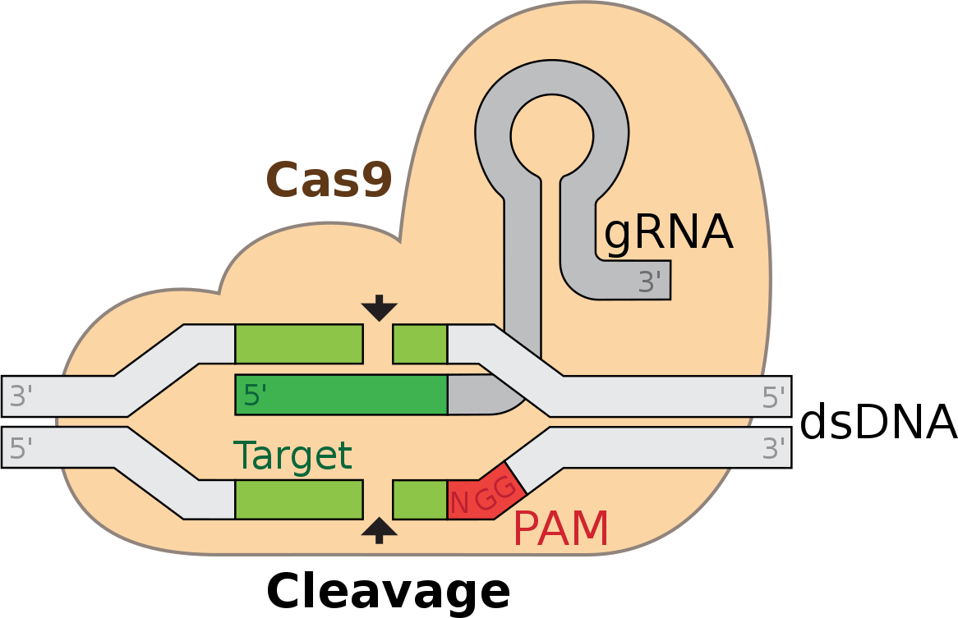
The protospacer adjacent motif (or PAM for short) is a short DNA sequence (usually 2-6 base pairs in length) that follows the DNA region targeted for cleavage by the CRISPR system, such as CRISPR-Cas9. The PAM is required for a Cas nuclease to cut and is generally found 3-4 nucleotides downstream from the cut site.

CRISPR

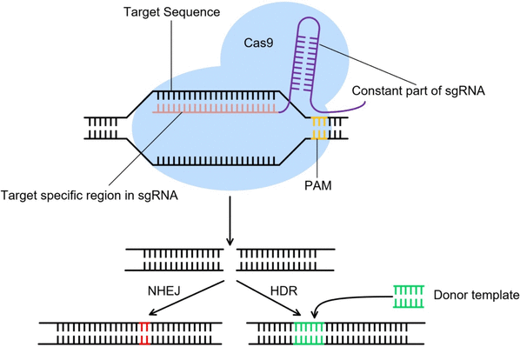

Cui Y, et al., Interdisciplinary Sciences: Computational Life Sciences, 2018

CRISPR

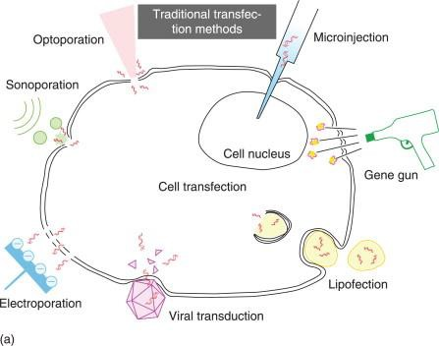

Ding, W, et al., Applications of Nanoscience in Photomedicine, 2015

Thank you for your attention.
Any questions?

Please feel free to contact me @ adrianna.dabrowska@ucsf.edu

