In Vivo Disease Modeling

Wanpeng Wang Kornberg Lab

Outline
- What is in vivo disease modeling?
- Utility of in vivo disease models
- What makes a good in vivo disease model?
- Examples of disease models (, , , …)
  - What made it a good model;
  - What methods were used;
  - Implication of the results.
- Ethics
- References

What is in vivo disease modeling?
Use live animals to study disease
- in vivo
  - (Latin for "within the living") complex biological system
- Modeling
  - devise a simplified description (of a system or process) to assist calculations and predictions. [Deﬁnitions from Oxford Languages]

in vitro (Latin for "within the glass") In vitro models are defined as synthetic experimental systems that contain living human cells, mimic tissue, and organ-level physiology in vitro by taking advantage of recent advances in tissue engineering and microfabrication.

Utility of in vivo disease models

- Understand disease transmission (infectious disease);
- Understand disease progression;
- Understand disease mechanism;
  - Identify disease causing genes/mutations;
  - Study the signaling pathway or gene regulatory networks that underlie the disease;
  - Identify genetic modifiers of disease phenotype and potential treatment
- Drug and vaccine development;

What makes a good in vivo disease model?

- Genetic diversity with well curated resources;
- Produce large amount of offsprings;
- Short life span;
- Tractable experimental systems;
- Cheap and easy to maintain;
- Resemble human physiology or disease symptoms

What makes a good in vivo disease model?
Genetic diversity with well curated resources;
Produce large amount of offsprings; (3-14 per litter. 5-10 litters per year) Short life span; (26-30 months)
Tractable experimental systems; Cheap and easy to maintain;
Resemble human physiology or disease symptoms (in some cases…)


Hutchinson-Gilford Progeria Syndrome/accelerated aging
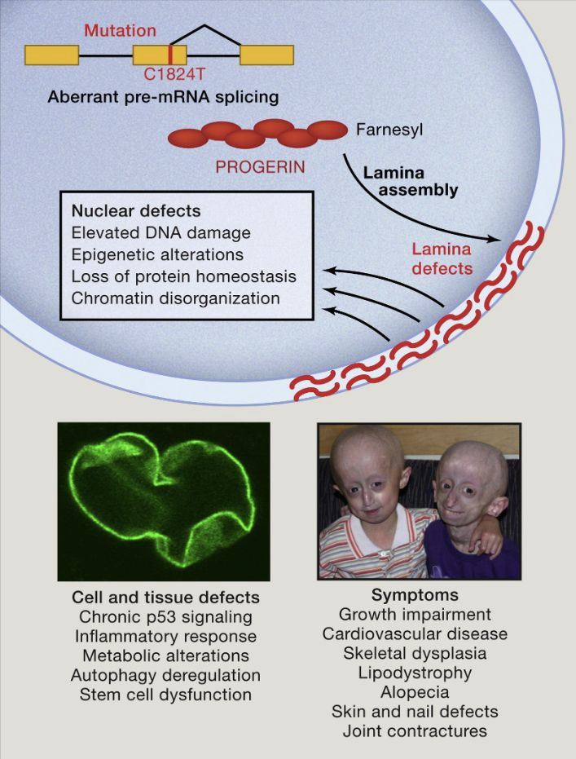
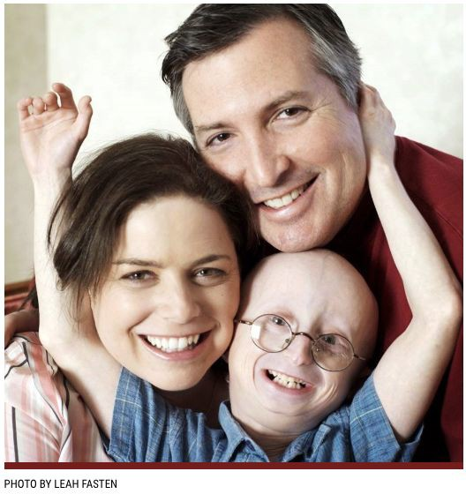
LMNA

TIMELINE HIGHLIGHTS 1999-2021: OUR HISTORY, OUR FUTURE...

1999
M1N:h: Th• Pr,)glrla RoHM:h Four.datlon
(Pi=tF) lic lfll!Orpor.llad M: :! Mllld.adlu&et\l. n01'11)�ta Ot;MIZ1ilon. Or1June II, 199U, the Bo� l){Qlt,e,c:IOl'&hoh:1&!1t l'll'tl ��

AUQUll: PRF awa,,H � 1tJ.(l'llflMrch(/mnt To dal!io, ?RF ha� 11w.a1drid 77 grants lotallr,g ov1r $9.-4million. TM pr$eUhaw- aJowed lnr'!OVriver-rchln�riatolhli,/1
2002
J,1nu1ry: TMPRFG4notltl COotOftlum II
klr� wlU,lhl ijWII ol llmilr>U111• i;,.mu kll PTogtda, which wa1 accompikh.it ten 1'110lll'llloll,erl
Marett: PRF 1Auncl1M me CBII & T\sl.l.Jfl Bart:: al Rhodfl lslarld Hospital, providing 1euarehflrslhfl�ldoglealtocil1nM1dedto
adllllI'IORPmgarl■r-at:h.Thl!IBanlt
2013
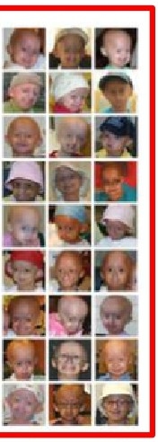

Janury; �80/:'llm'sUfoACCtXOing

April: f>RF'1llrwt ■nnual 'ONEpo11!bl1' campaign •�tffl.fuHy
2007
April: BCll10n0tilonl�(BCH)
l�dHHltl'lol'ifi&t-.-,erProi,arb CllrilcalOrugTrlll.f..il'l(jf(jancl oc,.C<)(Jl'(linattd �PRF, t>l'lnglnQ � cl11ponlble,tn111il�ntfor(:hlldren Wllt1Proo@lla.

2008
Oc100lr: In I 11.1nnlr,gdisplay ol
prograHw1lf11h111FTld1uy,11nd pr<Wlodlng lurtlMr conllrmalloo of how P�11rlf.111rctlm1yllllllpmlllon1 wlU, hear1 dl1111tH, W, NIH 1tu<:1y hdt lhtl Fll'1P,llvlklt lt11 Me41OkHtot-lnQ lllll'/l,Cl Ill Pfog8M h1l'r'llcii,:
CE110lo�ucul1rt:h1111.

2009
cnep®�2.t9le.
to s.,.,(U.Tt} doln,w •1 lh•
Sundance FIim FHij'l'III, F-■.Wrtng
:S.Om 6om111no;1'" �e,,or1ts (PRF
,:,o-burlCl&rs)Cll's.L&slflGcrijon11rw:t
soonBftl'M. lhllrlvMlngdOCtJm.!r'lla,y
aboutlOW1,llf1andM�fore111dren wlthf'togerilre-cel\fei:lan Emm'y, P•abody ;and Chrls.topt,,r Awards,
2018
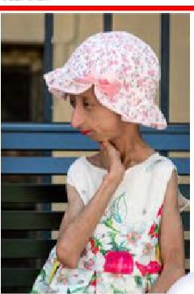
Apf1l:ln.tt?9ct&oul1rdo�lf1l,lf\ll',\'
2021
JuuaryandMarcn:&'l■kIhro.igh1tu0111on
P�r'lart't()IJl• mi:x:1.i., OCt-1� br PRF
�.,,..,.,.,,"
IOd 00-111.flnorod by PRF'1 t-.lec!lcal Onc:tor
Dr.LtthGcr
•.I t
I
Nn/ur1tMedkln#I ,
Onltsll.J!fy1rKlV!'S
11\81 gemllle.o11dllir"1Ign mice �n c.om1el th& rnu1.atlon !hat <:au1t1 P,o,gella. lmpro\fM H'lll'll'31kl'ly OIMMII symp!OmS, and
dram■ticalty in<HIIH ll11pan In 11M mlc.
Th• olMr ■tudl•it uMG RNA thtr11plH le roo'Jue1U>0!011lel)r0toirl,o,ooer'l'l,llld lr'np�vtl!dtur,,lvlll1111111>mk:11.Addi'tbnlll
Jw�N,.,M ..." na ure
do
n,
,
p,oc;llnlc:ol•ll.l(lh,ooronoodkttolo1vestlgolo
lheH l'll■ullS, whN:11 M hopl will or,a(laylHd lo11dlnlcallrlal
stV(jypublh:t1tdlr1TheJOu�<>flM Arrl,er1C&'l Mlld1¢11AHOCio�l)(I (JA.Mi'.) &l'll)wt 11'11111lor',111/1mlti11�16ndt llHl)61'1In cM<!,tn wl1hProg,o,rlll.Thlslolh&firsttNldllr11:o11th111t lor,;afamlt:ilmp,10Y4111iM1c:t,ldr111n'11ul'VMll-1 11unartrabifl f111at that d111mnnr;;trallls our wol'1< I&
1111lilt1ng.-ilong,11.11r�1llva1!0<lh&m.

Nov1mbff:PRFlaunche1i11W11b&lle,11 oompreti.nlhl1r11oorc1oflnfomlll!lonon P�1r11 klr ruelireharw, famlllH ol c:hildr-en wllrlPrcgori111ndlt11lrpt1y1iclilM,1/'Klttio Q.,,..tll)ubllc.l0gtll11r'withlQCilllll'l'lll!lc»II
oontain1' tho!Jsands of samples ar,d eel lh-H. dh�buted lo hoodred5 ol hllxn,lories In OYlllr twodozeneoootr!H
The PRF M4!dlcal & RHODfch OatabaH hi
(l(Hlltd, to l\41j)-IHM rflOJl lliX:lo.l lht iJiHaM
andlflnf&sn\falawan:ls.

Dtc•mNr: Sam p,re111111.td hll wlldly p()pullrTED• 181�, "M\I PhHOMlpt,ylo,
I Happy LIit." eoo,IN• 1111d LATS
l'lrlv•1<11.511\11'tils-td tw,111r111u cl Pr"Og1rl11 Olr'ld UIII Wl"1!)0rttinc. er
May:Onlt111Mlll1ol lho11 JAMAstud';'. PRF partnwswllhElger BloPti.lrmaceutlc:al1lo PIHU• U.S. Food lr>d 011,1i;aAdMll'IM1t•tlor1
JAMA
.JO M..tll'
1

1111&1 (11Htl� I mllMc,n FICOl:IOOIlCl)IICwlll'II). mlllon1 lll'Ollnd Iha world lc.10¥1PRF'■
pMgrMSM9Ul1ufy.
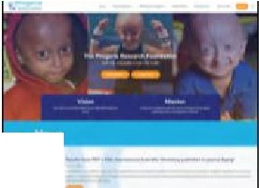

•I

1999
Md p,�i,e li8&lt'liefll reoorr'11Yutnt1Mlor!t.

rHChH 01# s.100,000 gl)III.1o dll11, ONEpolllblt tupporl.tl'I hlVO rtlHd $2mmon toward• malo.lr>g I CUl't POSSIBLE!
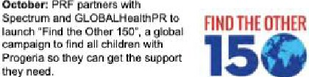

To dalll, aior,g with olhar public
11w11rans&a11frQrta, PRF hlls !«methulilredm of chlldum with
P�.t lrom mor. lhl'ln 65eooolrlH.
PR,..,mlHlon,rnlJtj"1'llnllrl1J"ll•eceofntff9'Jr�ln wo�ert,,IO(:lal m«111 orl)lltil\Olfl (111(1 "111�1�\1111'11181 In 1r.tis1 1'$1'1'\11rlulbl& chlldren. T0(!111y, Sftffl'S t.111�Is 1M � mnat
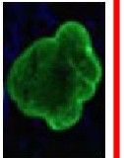
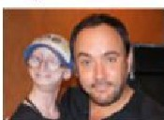

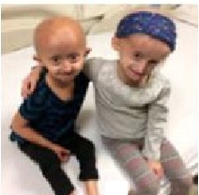
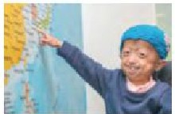
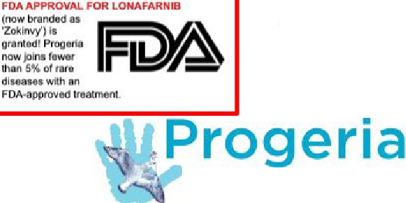
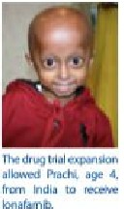
YMlw.cl TEDx talk, with ow.r S5 mlllcn \4-!
i�10\)etMI will bll •�en
20]6 NEWDRUl3,ANDNEWHOPE
.t.s)rll: Chlldre11btglri to 1rwoll �OR Ct41.DR£N
In a new, 2-drv(I trial with WITH PROGERIA.
IOMfamlbl)ju&f!Vftl'OllmuS.
2003
May: PAOGERIA GE�E DISCOVERED!
UYig �Is Immll'lfl PRF
Cell &. 'Jig;MJ11 Bri, f>RF
G6n11tlc1Consonll.im m11mb&nDrs.Marla Erlkuon and Fmndl
Col�m1l111citha Ptoya/lll
gtr1todlKOY«y.�blillhlld
... thi11Joum&INt1h.ir11.

Jur111:lnth11wa1Uoilh1
go11r1ediao,vvy, PRFlfllft":h" 111Pmgerla Dlagnosllcsf>rogrlll'Tl,&nlbH�Hr111r dlsgnosb, fttNM mlsdlagMSes 11'1!1 Ml'ly mtdlcallm&l'\19'11iot'i.
2004
AuQu11I: PRF IIW8rdl ill 10lt, fOHllfch granl, ILJIIIQl,,glheae■Ucr,of11Prog9riamo!JH.
Ar'ilmtlrno<Mlt!)ro.1dat1H!'ltlalprt<:l�tll IHtlr,glor"'"O'Ugl,
2010
"prtl: PA:f PIJtllilhlllhlllrlt ProgtritHllll"IClboOk.�G..-Ot
lor F,tmillie. a Htolth Coro Provii:Mir.olChlld11tnwll'I Proget1111
2006
Jun.:PRFlaur1che1apublle.sarvk:e
11nnooncnman1(PSAJ aim�lgn lttatur1r,p YOlcH ol' loo{I-Um1 f>R.F tuppon■ra Ted
Dtnt.Olli1nd MIiiy SlHnbutgtn. PRF hH sl,\c&a"1110ll!dtNl1)'
PSA1wlrnct11tr
,;olel;will&0.�c:k.lclln1t S.,.lonBf\ni:,1�1'11 and Dave Ma!thl'!WH.
dn
\loitlltn11M,ptl1r11111hllt...o
S•pt&mbu:A.llll'ldmtlril1tll1fy l@dl',yPRF'smfldl�dll'&CIO<, In pMtnershlp with NIH, showg
1tmlhtProg,ella-caufflO prclalnprogerinulsts111nd lna11H1in1'IClryofMIIIIM t{lll,TtHrittu(!yeoMlrrl'lllhal byi11.urrnlnlngcnaoft11rt1Ht
dlHaHI, WI'j!aln cn.idal 11'\t,lg� lrtto lhl hilllr1difflH that
erfec:ttmllllon1.o.ndthllll(lln11o�dlrig1,111111,
nw"e&ffec:tm than lonafnrnlb
2020
Novam�r: PRF holdl itli 10th .-iteiNltlor\11
&d&ntllh;: :;,1'1'.shop, wlthov11r :l,70r&g1Wan1',
from M eoL>l'IUift1coming1,:,g11lhllr on Zoom to shal'l!lhl'llalflMllnd�lnf>rog@riaMM!arcll 100 hear 1rom some of lh@ lammes belrio
rn'llpfldbylhflirwork.
We've come so far
ln such a short time.
With your continued support, Together; we WILL cure Progeria!
2017
PhllH10(lhl2-�U11111s
Complflhtd,fl!'lciil'�l
�lnti.PhaHlcltttrmlntd
ll'l1DilltlOllHOlev6f'Olimul
✓
IOglvotho,;hHdrttn. Pht11$$2 Zoot., o.ft,lnd C•le;, '"""' I� !he
Mission
To discover treatments and the cure for Progeria and Its aging-related disorders, including heart disease.
F11bfua,yJJuly:
PRF..ftlndld1tudln
fnd that r.-1H1sybat111fflfllMI lnhibilOIS(FTls) 11ra11f>C)4enlilll!rf!111t�ntlcrfJra'1trilll,Hf1ey pra�1111aomt �nt1orolu.au 1n Prog.-ia mlol. Tl11H 1rid otlMl1 ltudlol, llor,g wi1h
dirul 1nolyzod from PRF'■Mtdlcal &
Re�aren 04\lbast, P8Yill 11\o way kw a
d<illllmlnMwf'lltl\ll'U\I r::ombln1ttlonlh■rapyll eff11c1Ne.Ctrlldm1frorn27 001.mtri111s,11r,saklng21l lar,guages, COIT'MI to Boston to partjdpate.
�ndoodl-dri,glli.al.ol.lm<OII
Chlldrn\111(»�•-
Research Foundation
FOR THE <:HILDA.EN• FOR THE CURE
Mro.U1•11r1oldtr1. ,.lr°"'b,plnt0
2012
So11ptembu:
FIRST-EVE.RTREATMENTFORPROGERiA DISCOVEREDI
PRFm11,klls hlllOI)', publishing tri.11rMUll8 &hawing Iha! e"lfJf'/ chlkl 1xp,1r1.,,c.i:1lmpnw.m11n1 In on• or moro 1r111:1, lnd!Ji:llng lh& vllllll car(Slc)'ltlacull'll' ,y1111m. WIit\ 9 Ollllnlllve llndlng 1111111 driJ" (lormf,rnlb) llt11ed!hi Prooerkl i:IIHMll l)JOOIH, IJ1t
<l-"'t-llorlcurlllsltr<:,,oy■rthil!'l.,_111',
....
200S
Novamti.r; pn1:·•11t-tC!'liPll1Opirnt.ln
C.&llcmlll, Ch!lptetl, Hwel Hthou!Ml'li:1$ of otl'Hlr wlun1Hr1,WDrldwlall, nllici rliu l'!W.Uftfll!!!!.Sand,:;ooi:l,JctloclllflJOOl.i,lslr.g IIIVIMI In 1upp01t of PRF':1 million.

2014
J111r:wt1llfllPRFoonUriu&11!0M1al'ttllor
�afllfl!lcit,o11drugcandk1111tn,thtl PRF-fundtd1xi.n1lonani:l•xpanslonof lhllollrictlllialglv11ewfy0hildwi!h
Progorl8ooc1nlolon1f1mlt>.�i:INgtrlat
(:l;)u1clQl.-.1t11mlO�tl'lcir.t111l\l\ltr1tv.1.

201S
PRFcontlnuesltsrtmaJXilblllpaceof
proi;,rlllMI, woilclng onaffllJltilude olr&s&arm-l'l!lateclprot&ffl
andKhl&vlngarK01d-hli;hS1 milloninvls1m1ruln111111arch IJlllf1!�1hlsyMr.

Julr: FRF .and M,in;k mal:,alonafamlb 111111Nllbltl lo Iha ra1earch comrT11Jnlty UwGl.lgh !ht PRF Ctll & T11111t Banll, katOMg ma,ro bllllc.to�nc■t!l.di.ttllfurU\t1lnv"tigaMt11ton'tettof ionorwnlbo,,Progorla.
\FOAJ ll!ll)r'OVtll or1onaia<nl13, l'Ml'klro;itr.ie rot
Pr�11111rapy101:1t11ubrrw1tldtoU,1FD.A..

2019
DKlll'l"lb«: PRF't blof,t'iarrr.aowtlcal partMr. Soar, submla a N@w Drug Appl�l10tt (NOA) IO lh@FDA for lonll!a,nlb, Illmalor llllP toward
awrov11I H lhol flnll-11'191l'rHlmenl for Prcigeria.



2021

��
2000
J1nu•ry:PRFl11uf1Chnllllntom1llon1I
Plttlllllit A°'9ltll), m1lo11th'ilo1i1c.r1trllll1..:! k,fOfl'I\Otlor10,,ChR(ken"""'°IOITlllle1Mngu.!'1 P�Ma- This l'.l'(IOl"Sll'I a1s.,r&11 ftll)ld dlfilrlbl.lllon of MWlnlo,ma[l,:m that may benotfit 1h11ct\I1,hn.
o,,,.,.,,,,,.,,,,., •• �

lm;trumontal In MCUl'!ng Pro1JGlia-1ptcllkguldtoliM1 forttwlNaUonallnslitl/lHOI
H1alth (NIH)ln th1 2000
Ch110!11!11rl'l Hell�h Act. Aa I
fllul� NIH hff r&g'Jlill� IUPl)Oilld Pro(jllrta
tttMarttloifa'ta,�allPRFldard'ic wi,ricNl)I, o�nr,tul'llhlt111ll)' 11!,l(ly(If d'llldrenwllhPr(igtrill.'lh■�aTnpi.
Drug Trlal. and ?f&C:lillcal rNoflarch

2001
Nov,ambar. PRF holds Its pr11ml111 worbhop
In BethH<l1. Maryland. PRF ha.1 «"8nlzod 1J1ucceHfuladenU11cconrtrancHlha1 hll brO""UhllOll111Mlrtcientl111Qncl
dlnlClll!'11fl'Omlil()O<er\heworldWU'l6r•
thflll't>q:18rtiHandcutt1no,ec,oesol6rltJl'lt:
<1ala,■l'ldl01ttrcdllbor11lonlnlt)lol�
aga�r.tPro[IOrlB

dlnlcatcirugtnllu&lr,pt111FTt1onar1rri).

'°'"""'IAl>f<k<il)ot�"'1fll'Jo(k._gl.,,,I

Mouse model for Hutchinson-Gilford Progeria Syndrome
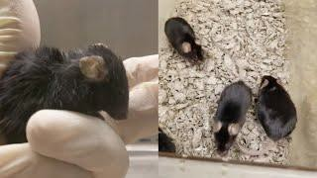

Invivobase editingrescuesHutchinson-Gilford progeria syndrome inmice

https://doi.org/10.1038/s41586-020-03086-7 Received: 9 June 2020
Accepted: 30 November 2020

Published online: 6 January 2021
Luke W. Koblan1 2 3 13, Michael R. Erdos4•13, Christopher Wilson1 2 3 Wayne A. Cabral4, Jonathan M. Levy¹ ² ³ Zheng-Mei Xiong4, Urraca L. Tavarez-4, Lindsay M. Davison5, Yantenew G. Gete6, Xiaojing Mao6, Gregory A. Newby1 2 3 Sean P. Doherty5, Narisu Narisu4, Quanhu Sheng7, Chad Krilow4, Charles Y. Lin8 9 12, Leslie B. Gordon10•11, Kan Cao6,
Francis S. Collins4�, Jonathan D. Brown5� & David R. Liu1,2.³�
• •
- • ,
- • ,
- • • • • ,

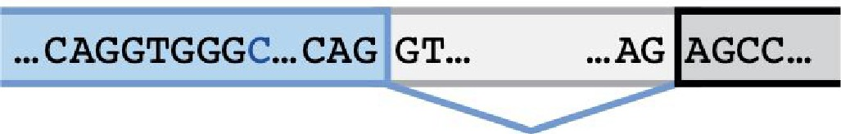
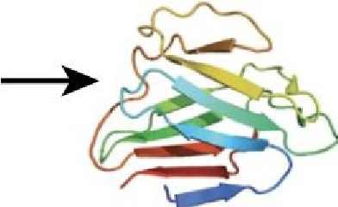
Exon 11 lntron Exon 12 LMNA mRNA Lamin A
a
. ...CAGGTGGGC...CAG AGCC...

t Base editing by

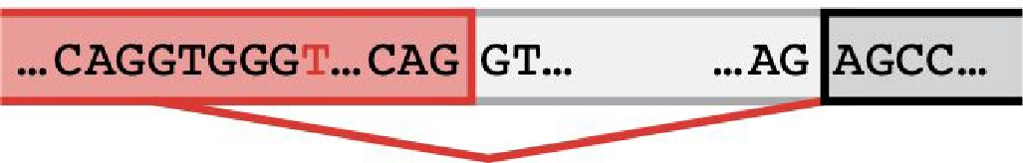
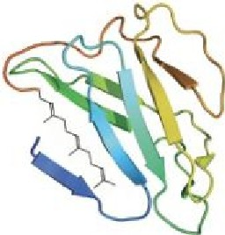
Exon 11 lntron
ABE7.10max-VROR
Progerin
Exon 12
LMNA.1.150 mRNA

. .

The Progeria Gene Team
PRF has been collaborating with an extraordinary team of world-renowned scientists and innovators. The team's tireless work and dedication is bringing this transformative therapy to reality:

Top Left to Bottom Right:
Francis Collins, MD, PhD- Longtime Progeria research partner and former Director of the National Institutes of Health (NIH) Michael Erdos, PhD -Associate Investigator, Molecular Genetics Section, National Human Genome Research Institute (NHGRI) Leslie Gordon, MD, PhD - Co-founder & Medical Director of IPRF, and the world's foremost expert on Progeria
David liu, PhD - MITs Broad Institute and Harvard University scientist, founder of Base EditingGene Therapy Technology
*Sammy Basso, MS, Co-Founder ofTheAssociazione ltaliana Progeria Sammy Basso and PRF Ambassador, was an integral part oHhis team until his passing in October 2024.



Going forward
- Best result to date in the mouse model;
- a number of the longest-living treated mice developed liver tumors — a known long-term complication when using adeno-associated viruses (AAV) to deliver genes into mice;
- Base editors may be less effective in primates (61% in vivo gene editing efficacy in the liver of mice compared to 26% in primates).
offers the most comprehensive set of tools for preclinical research (if the disease pathology mimics human disease well).

Duchenne Muscular Dystrophy (DMD)
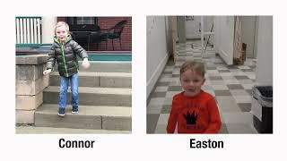

DMD is caused by loss-of-function mutations in the Dystrophin gene
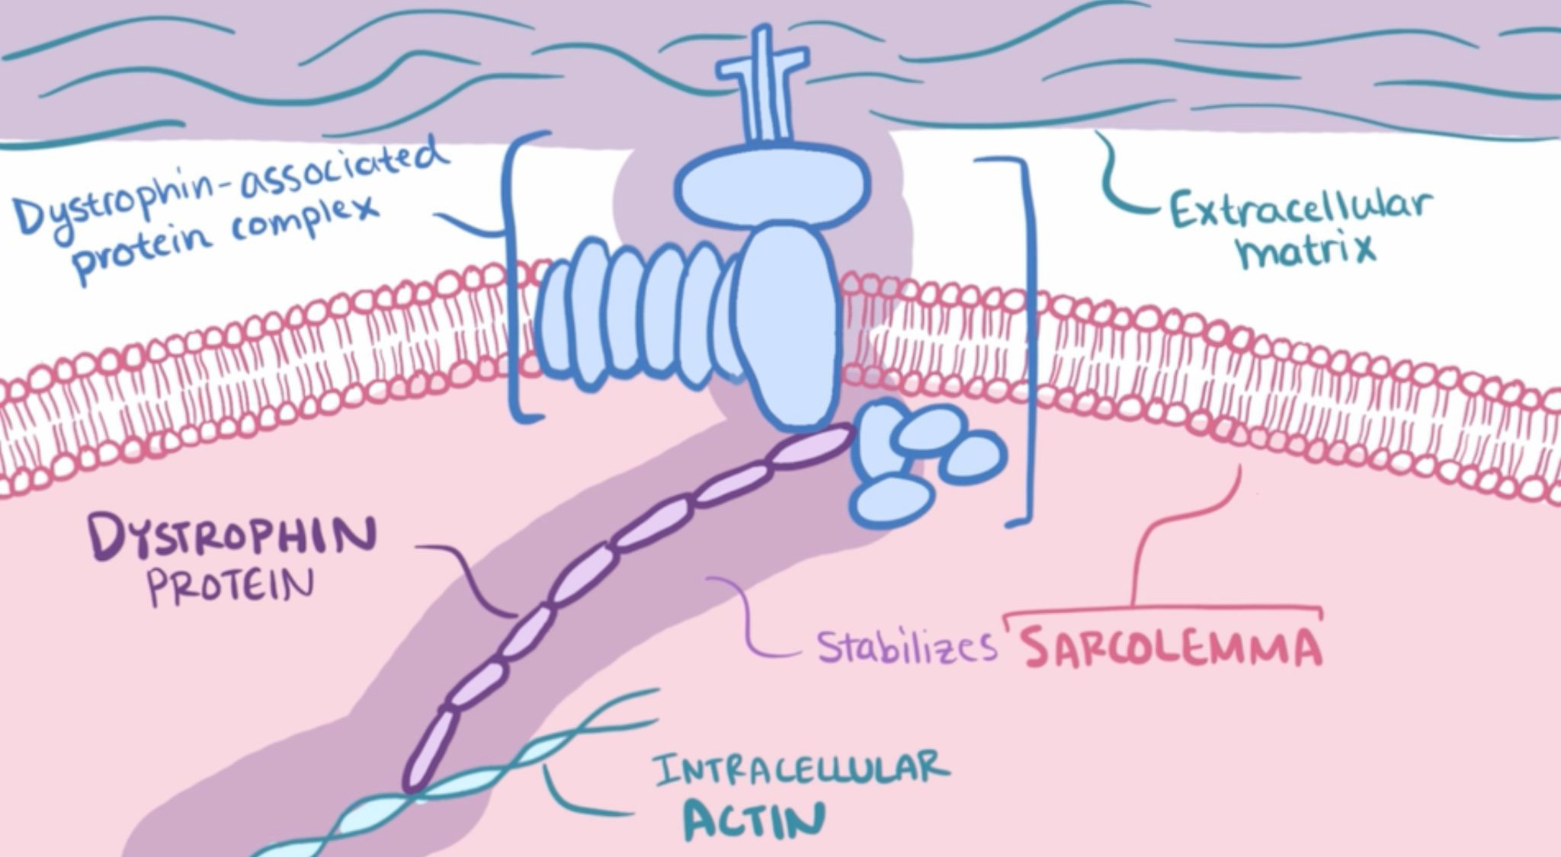
Merck Manual for the Professional/Duchenne and Becker Muscular Dystrophy

DMD is a x-linked recessive disease

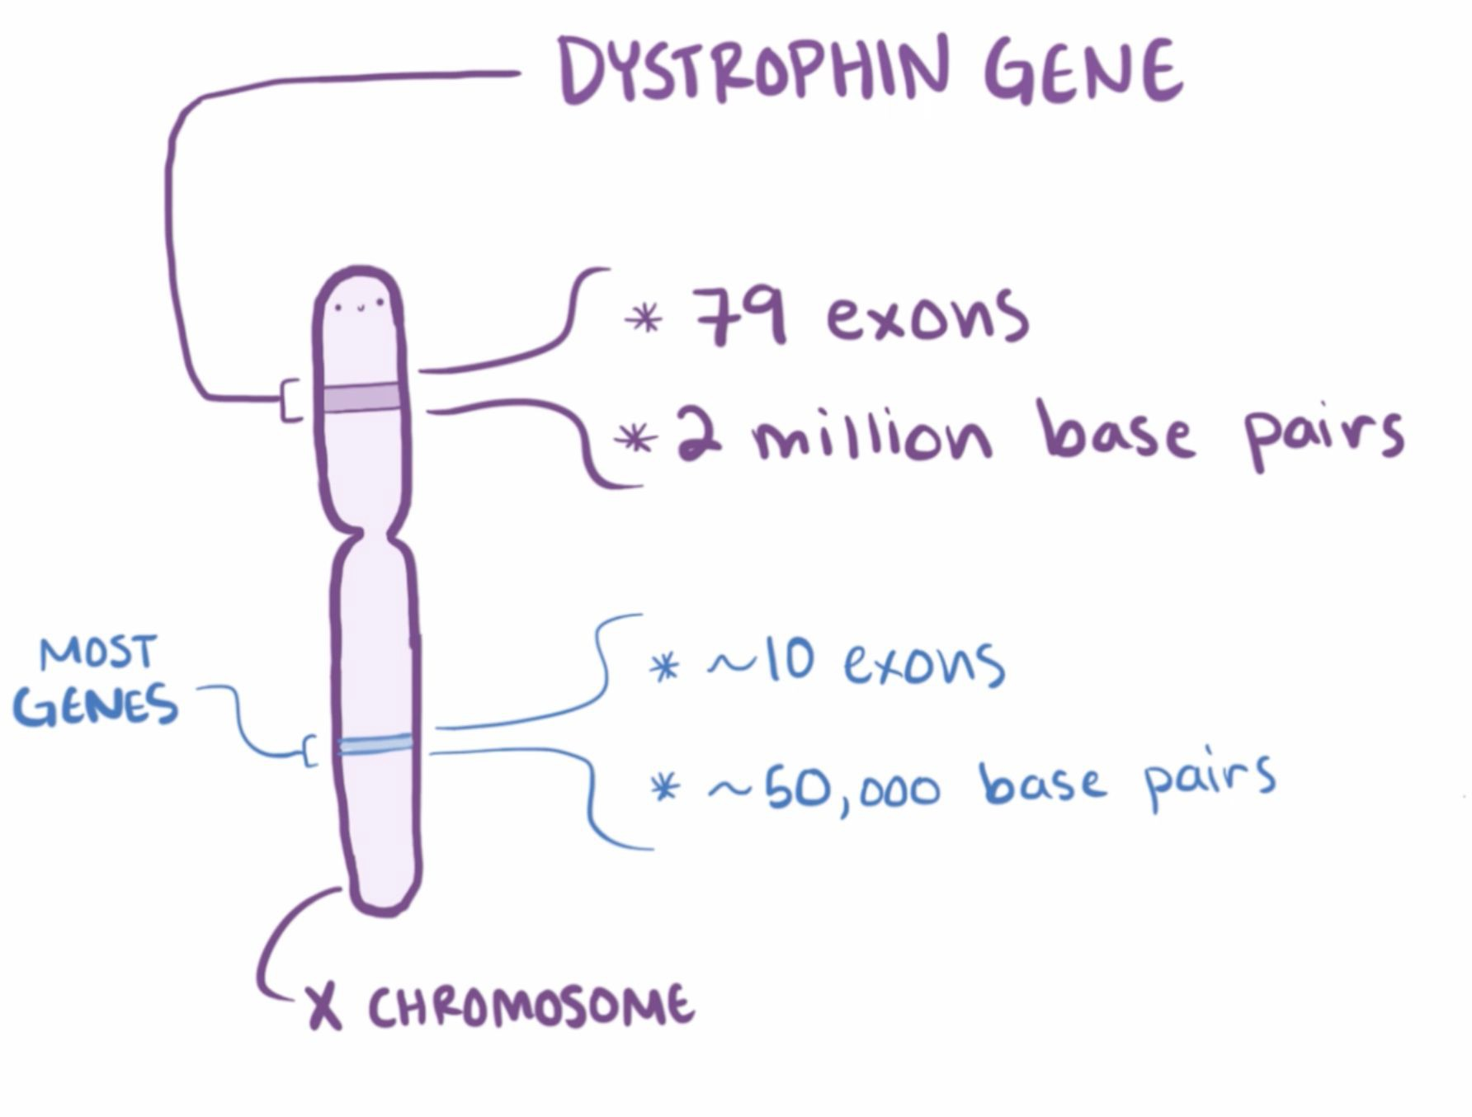
Merck Manual for the Professional/Duchenne and Becker Muscular Dystrophy

DMD is a x-linked recessive disease

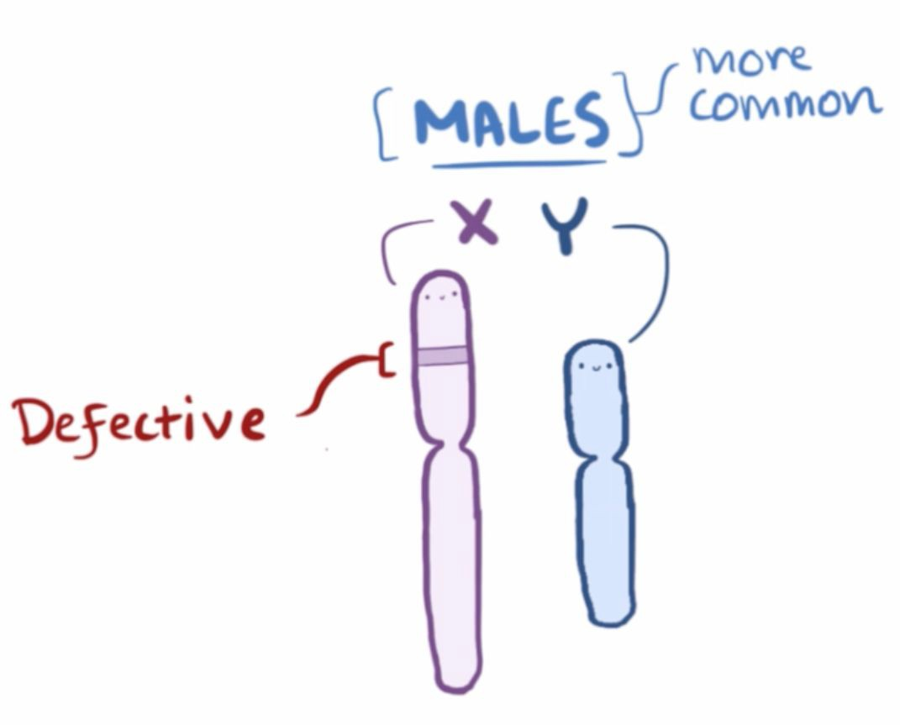
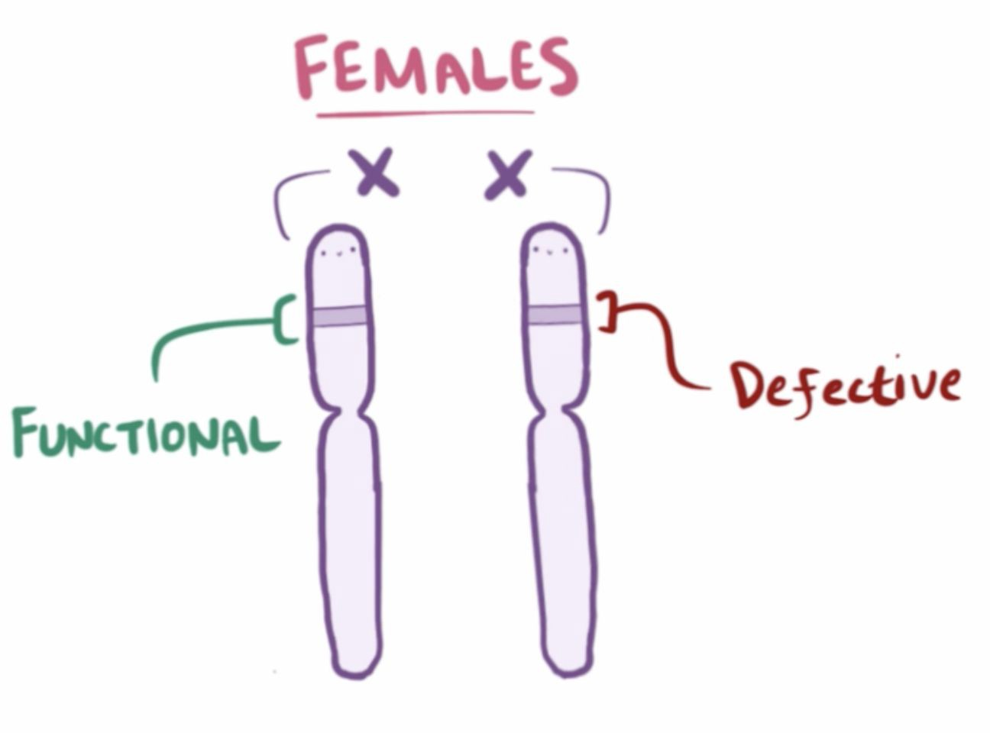

Merck Manual for the Professional/Duchenne and Becker Muscular Dystrophy

Animal models for DMD

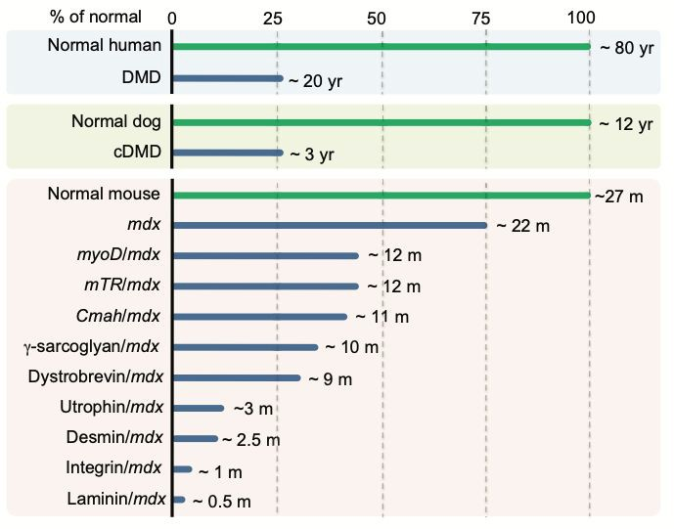

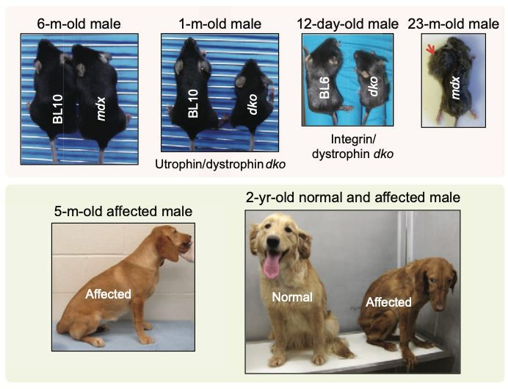
McGreevy, J.W. et al., 2015. Animal models of Duchenne muscular dystrophy: from basic mechanisms to gene therapy. Disease models & mechanisms, 8(3), pp.195–213.

Escapers showed same muscular dystrophic process as severely affected dogs

normal dog
escapers
severely affected dogs

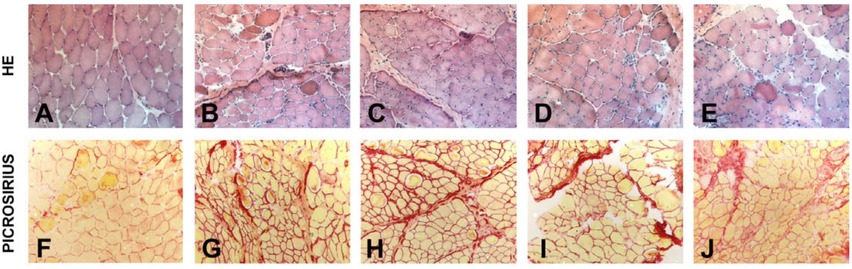

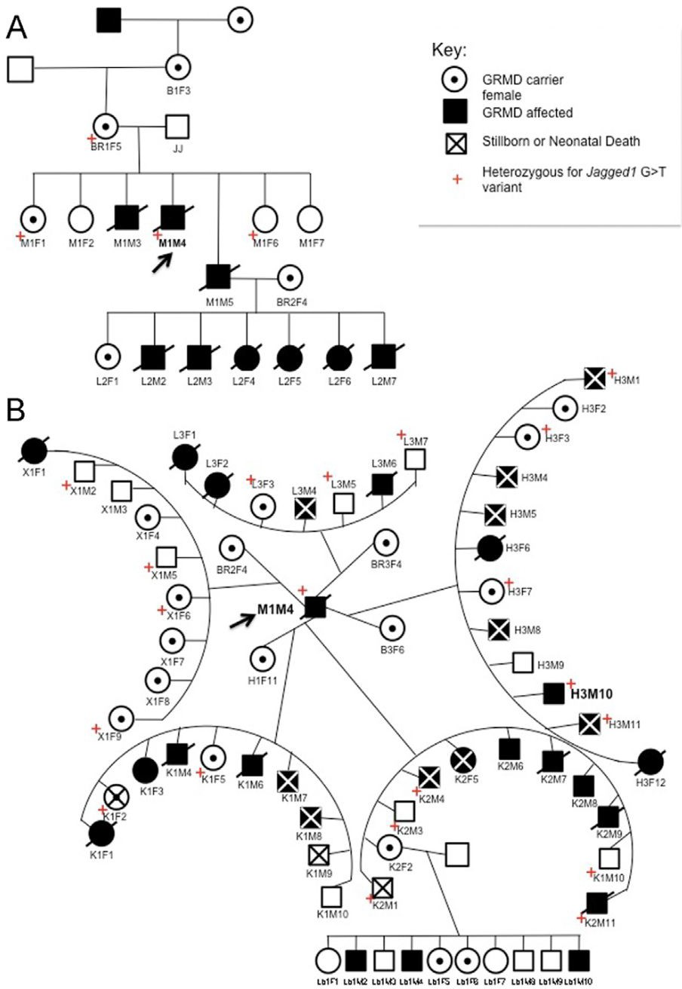
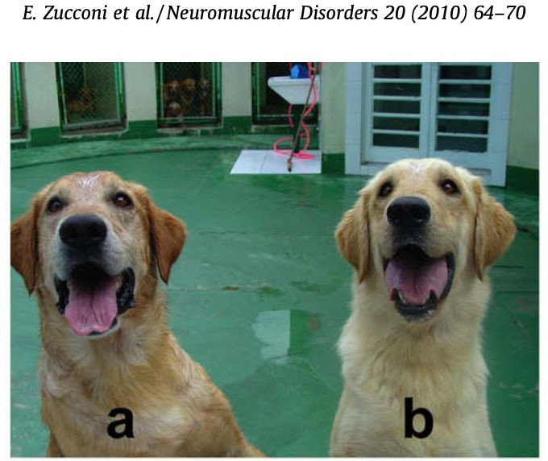
Ringo
Suflair

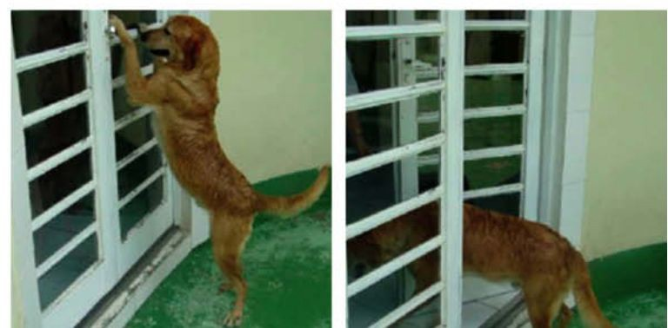
Vieira, N.M. et al., 2015. Jagged 1 Rescues the Duchenne Muscular Dystrophy Phenotype. Cell, 163(5), pp.1204–1213.

Dog breeds around the world provide genetic diversity
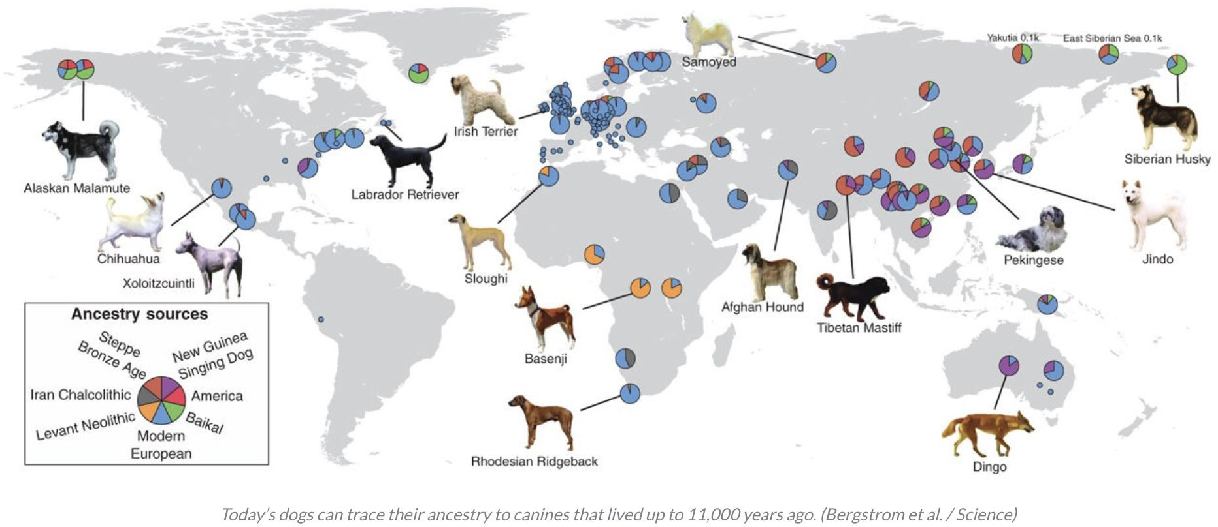

Dog breeds are genetically isolated populations within the same species


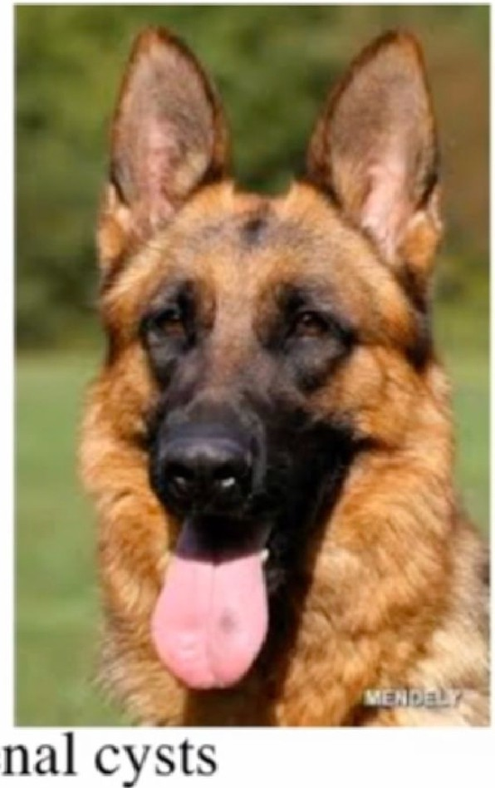
C,anine Hereditary ultifocal Renal C tadenocarcinoma and odu ar De matofibro i

)
(RC
G rman h h rd
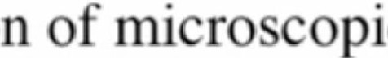
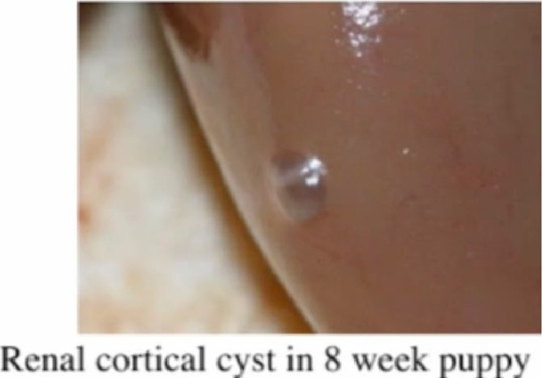
- kin-fibrot lli ul ma r tri h di ma
- Lun - t and pn um thora
- Kidn -7foldin r a ·nri kt r
r n I ll 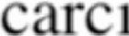n m tum r

Jona ·d llir I al.. 0 P ; Lin 1,w I al .. 00 Hrrm Mo! 11 r

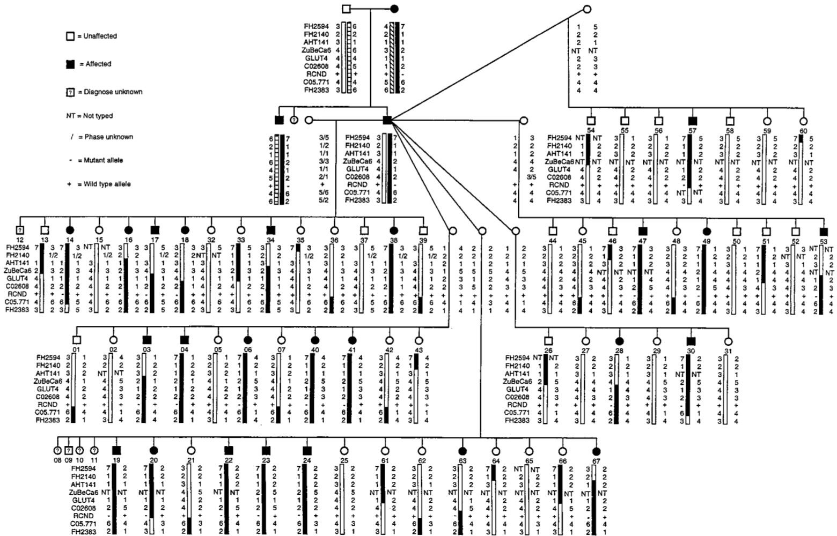

Jónasdóttir, T.J. et al., 2000. Genetic mapping of a naturally occurring hereditary renal cancer syndrome in dogs. Proceedings of the National Academy of Sciences of the United States of America, 97(8), pp.4132–4137.

offers powerful disease pedigree and population genetic resources
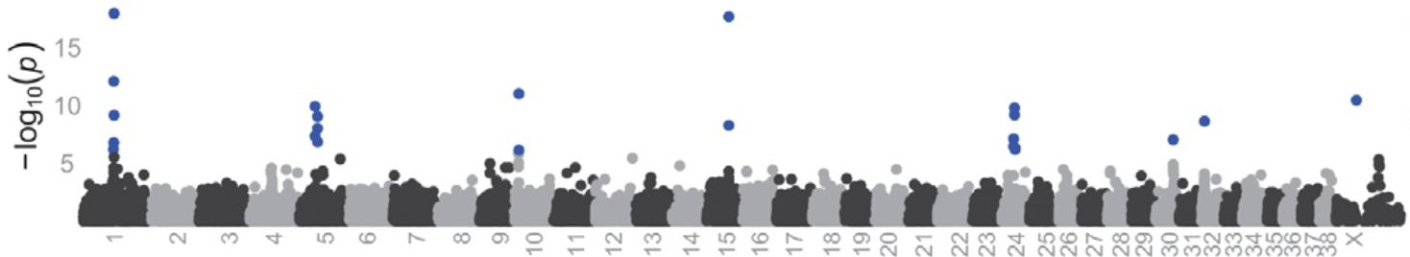
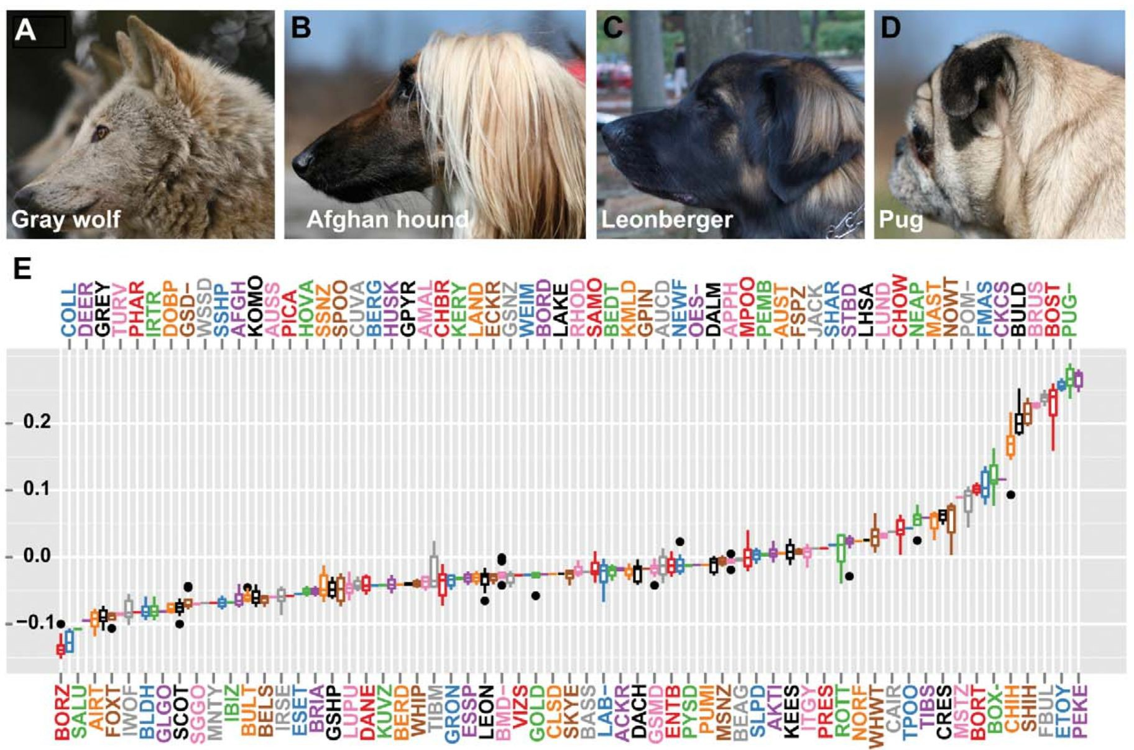
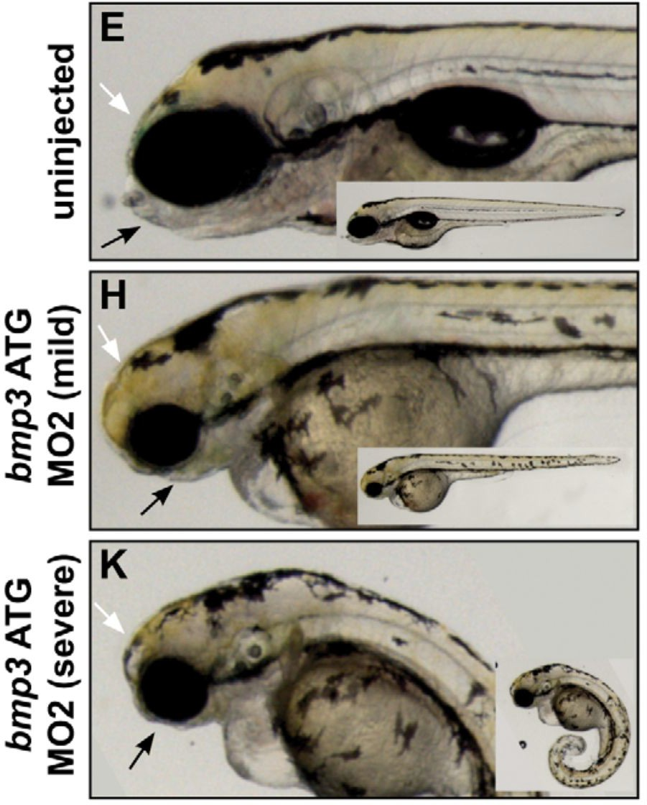
Schoenebeck, J.J. et al., 2012. Variation of BMP3 contributes to dog breed skull diversity. PLoS genetics, 8(8), p.e1002849.

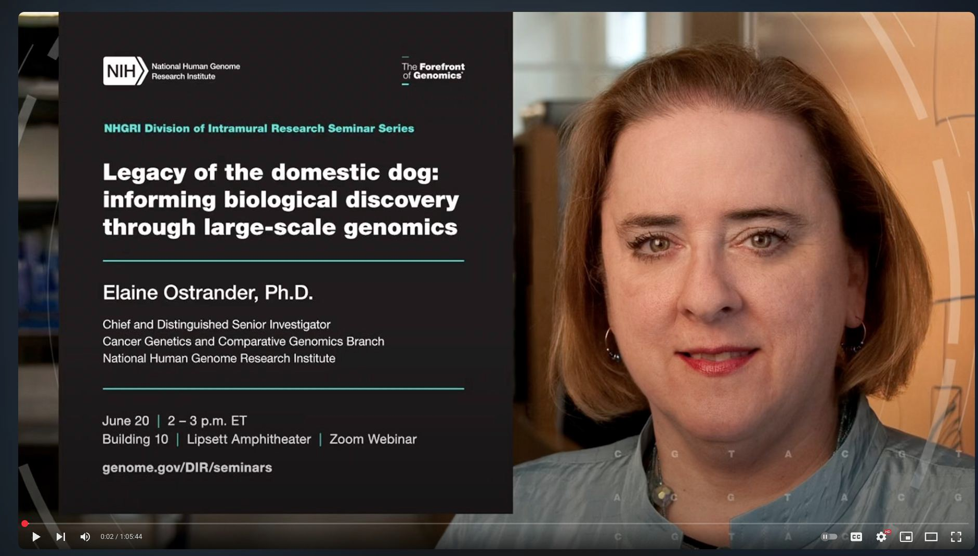

Further readings related to the journal club paper

Duchenne Muscular Dystrophy: Advancements Research in the Pipeline
FDA Approves First Gene Therapy for Treatment of Certain Patients with Duchenne Muscular Dystrophy
Sarepta Therapeutics/Duchenne: A Rare Genetic Neuromuscular Disease
Uffelmann, E., Huang, Q.Q., Munung, N.S. et al. Genome-wide association studies. Nat Rev Methods Primers 1, 59 (2021). https://doi.org/10.1038/s43586-021-00056-9
Understanding QQ Plots LOD SCORE
Ostrander, E.A., 2012. Both Ends of the Leash — The Human Links to Good Dogs with Bad Genes. The New England journal of medicine, 367(7), pp.636–646.
Dog Genes Tell Surprising Tales - Dr. Elaine Ostrander

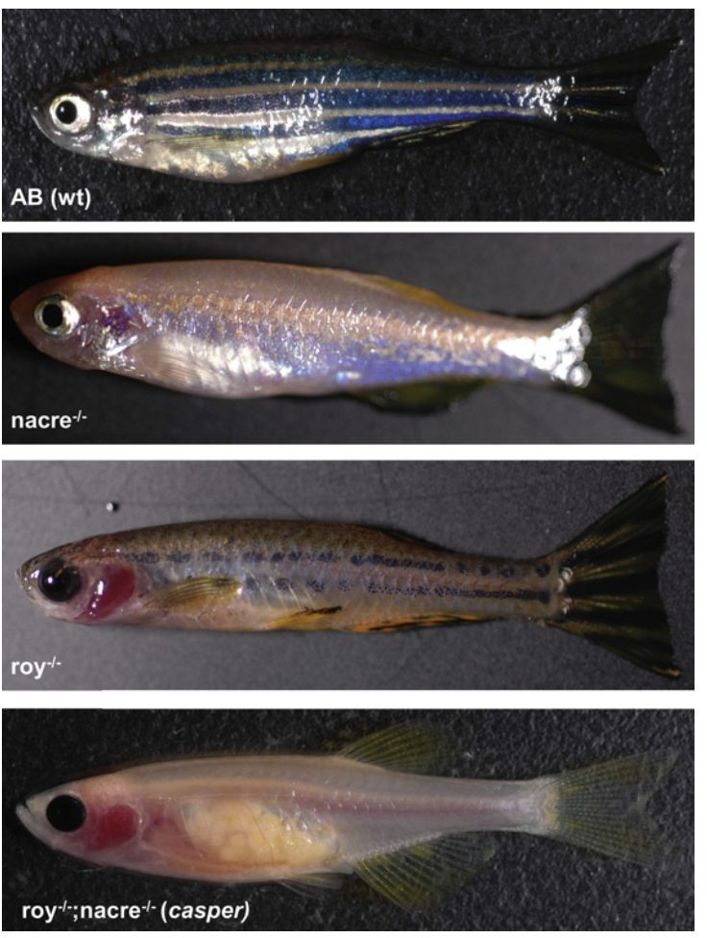
Zebrafish , a transparent model
The zebrafish is a member of the minnow family of fish.
The zebrafish embryo is transparent, it develops outside of its mother, and its development from eggs to larvae happens in just three days.
Easy to maintain. Not very susceptible to disease;
20 - 200 offspring in a single breeding;
Good model for chemical genetics approaches for drug screen.

White, R.M. et al., 2008. Transparent adult zebrafish as a tool for in vivo transplantation analysis. Cell stem cell, 2(2), pp.183–189.

Zebrafish model for bone marrow transplantation
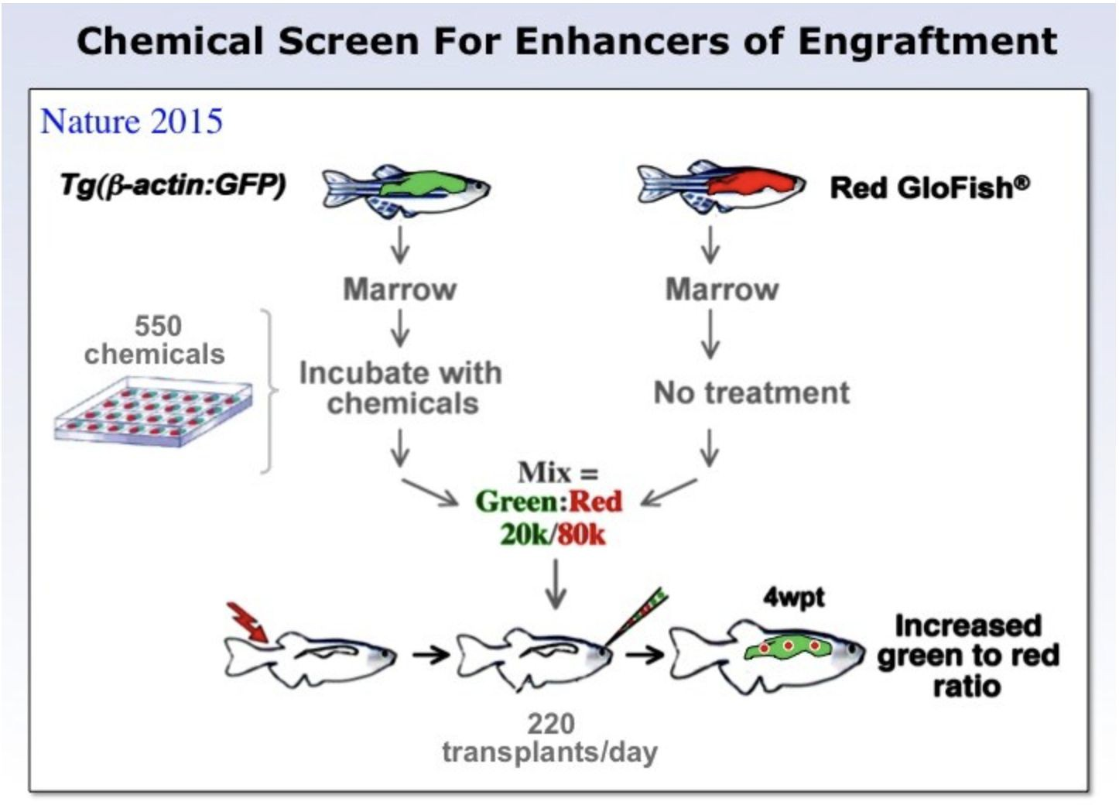
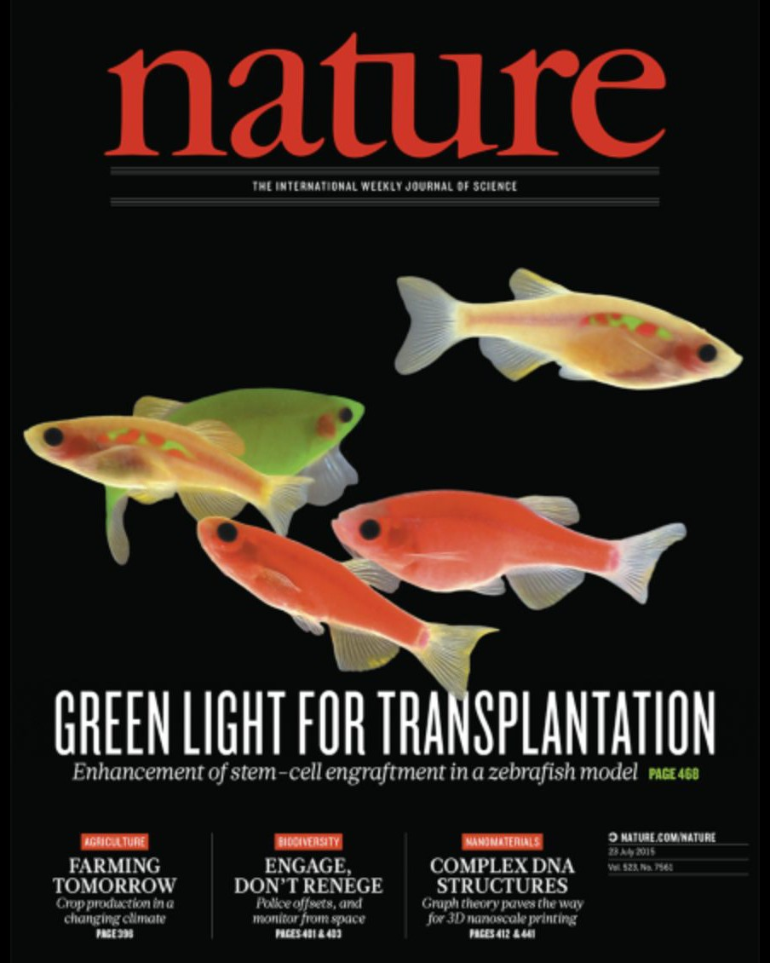

Zebrafish model for cancer metastasis
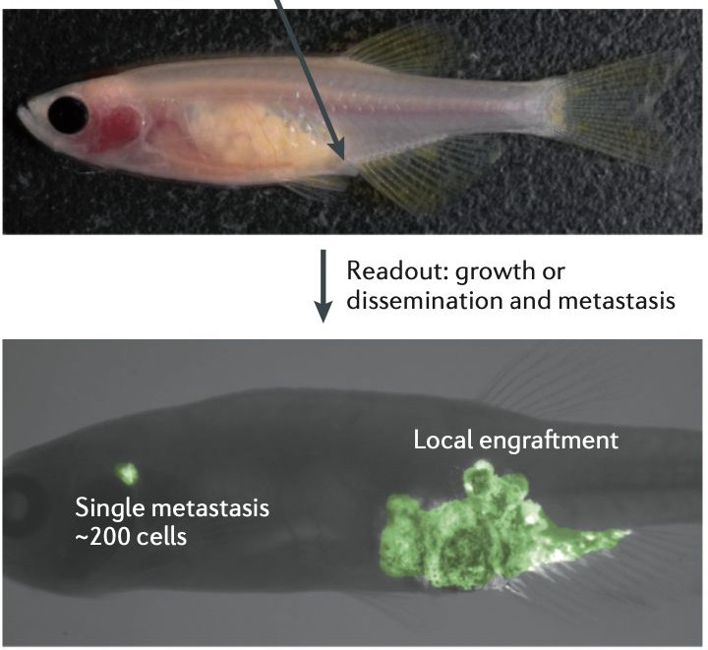
White, R., Rose, K. & Zon, L., 2013. Zebrafish cancer: the state of the art and the path forward. Nature reviews. Cancer, 13(9), pp.624–636.

Mouse lemur

Mouse lemurs are the smallest primates that are about twice the size of a mouse and live exclusively on Madagascar;
Genetic diversity in wild populations; Closely resemble human physiology.
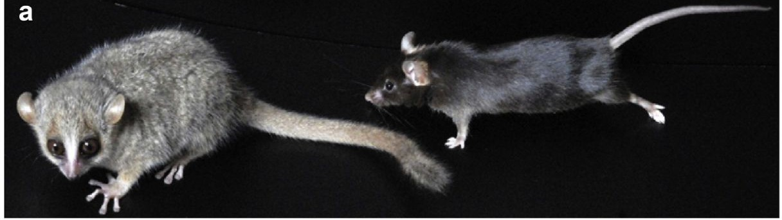

Ho, C.L.A., Fichtel, C. & Huber, D., 2021. The gray mouse lemur (Microcebus murinus) as a model for early primate brain evolution. Current opinion in neurobiology, 71, pp.92–99.

The Mouse Lemur, a Genetic Model Organism for Primate Biology, Behavior, and Health

Camille Ezran,*,t,1 Caitlin J. Karanewsky,*,t,1 Jozeph L. Pendleton,•·t Alex Sholtz,*,t Maya R. Krasnow,•·t Jason Willick,*·t Andriamahery Razafindrakoto/ Sarah Zohdy,i
Megan A. Albertelli,** and Mark A. Krasnow*,t,2
*Department of Biochemistry, tHoward Hughes Medical Institute, and **Department of Comparative Medicine, Stanford University School of Medicine, California 94305, *Department of Animal Biology, Faculty of Science, University of Antananarivo, Antananarivo 101, BP 566, Madagascar, and §school of Forestry and Wildlife Sciences and College of Veterinary Medicine, Auburn
University, Alabama 36849

The Mouse Lemur, a Genetic Model Organism for Primate Biology, Behavior, and Health
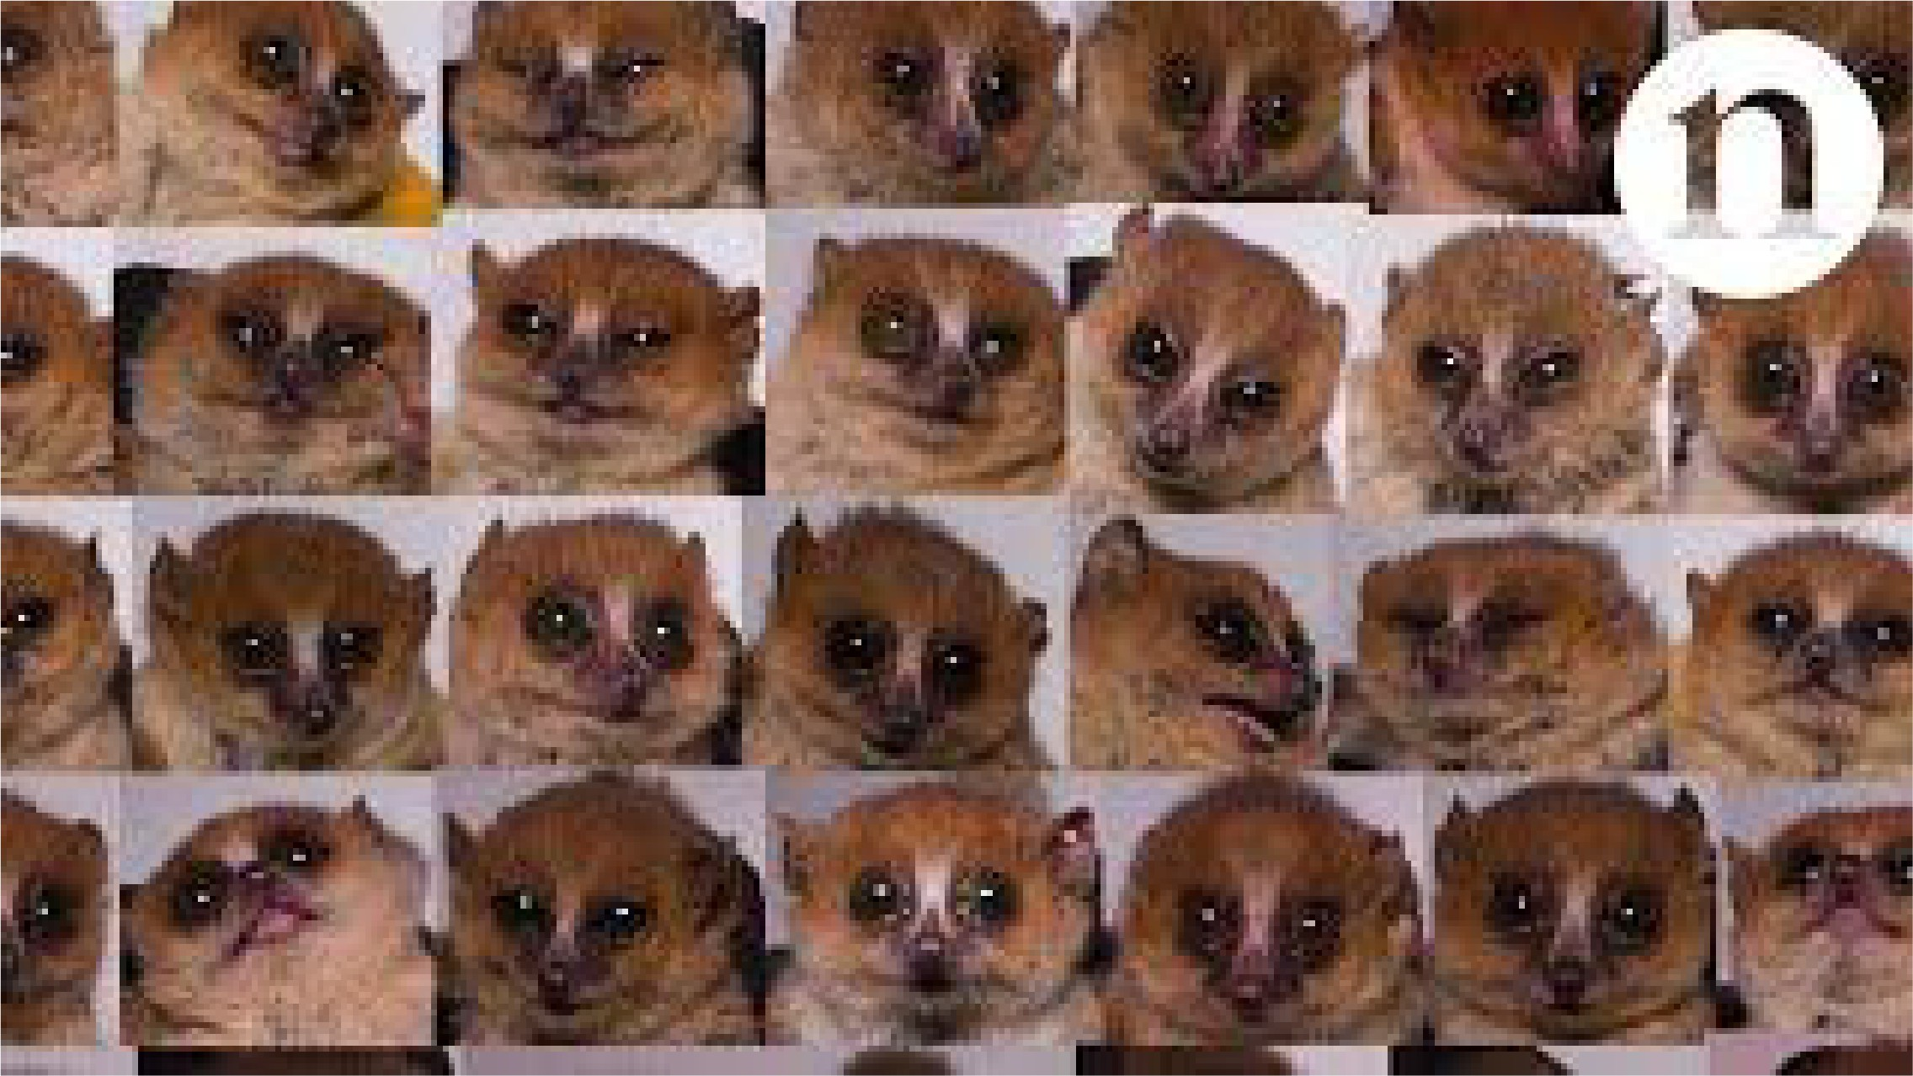

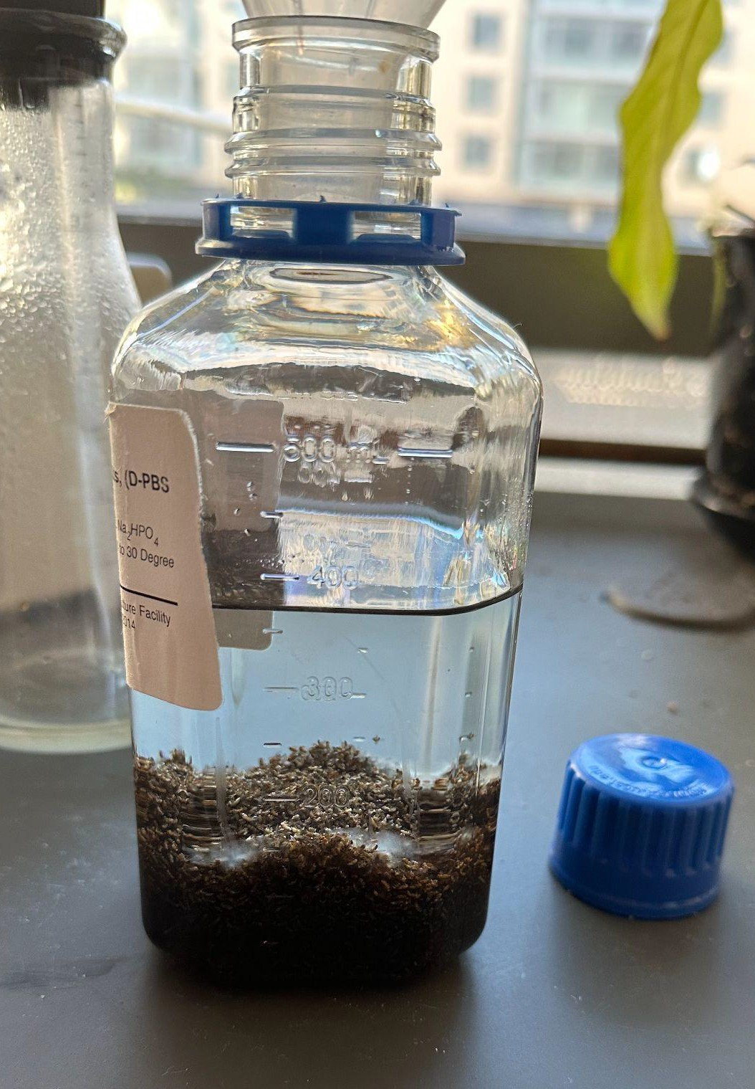
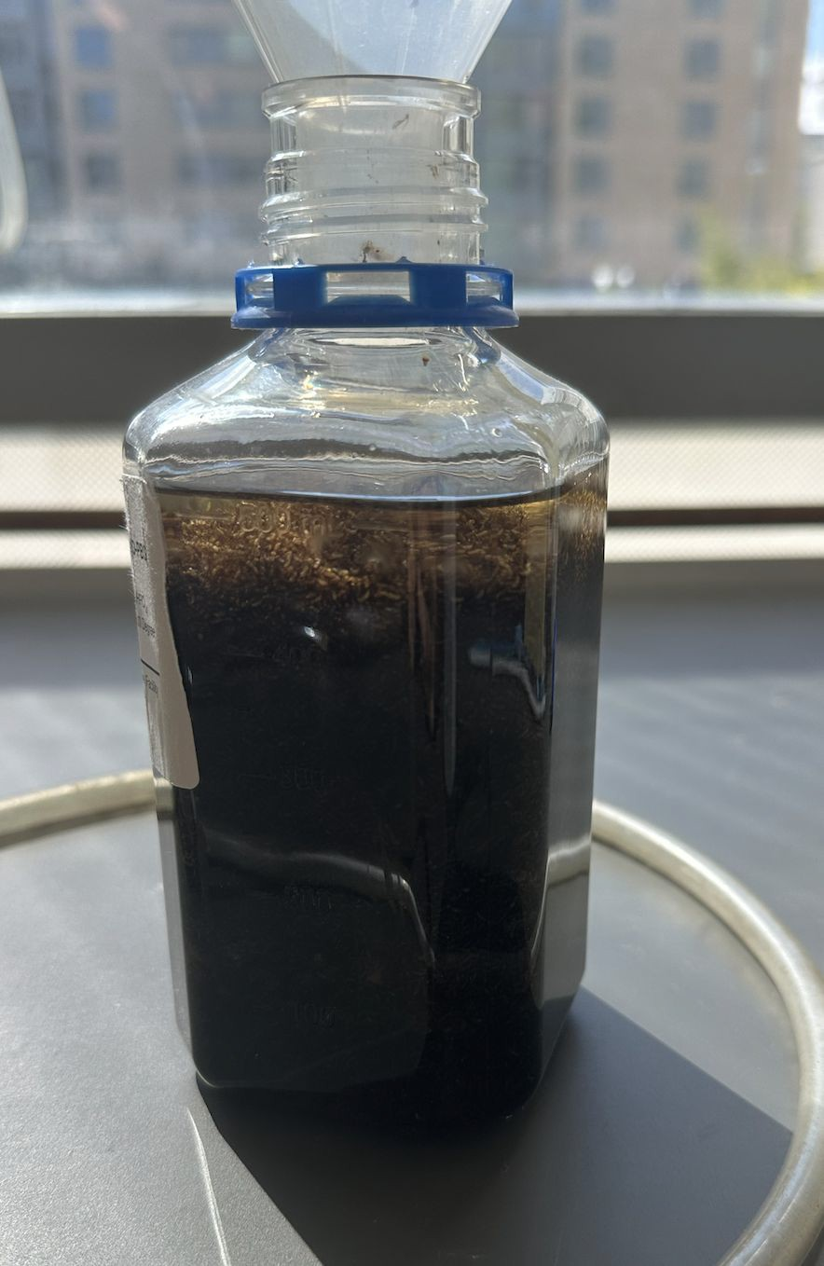
Ethics
- Diseased animals breed for research purposes;
- Protocols and guidelines to manage pain and suffering of animals;
- Improve veterinary medicine;
- The most used animal models are what we feel comfortable killing in mass.
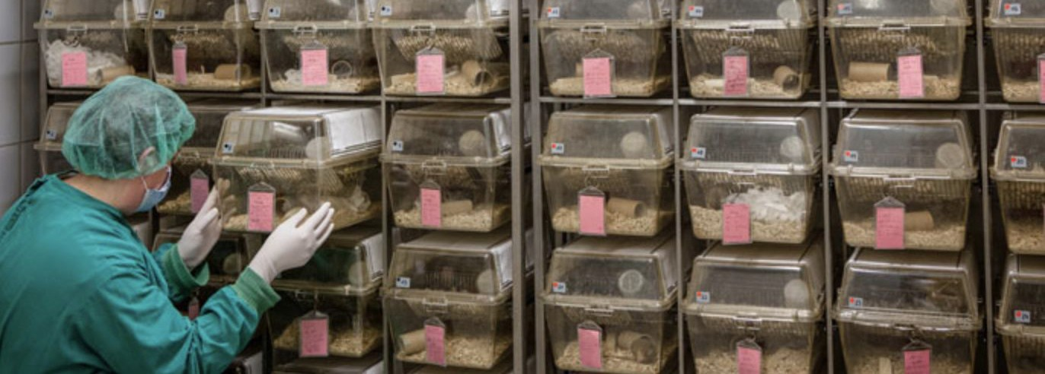


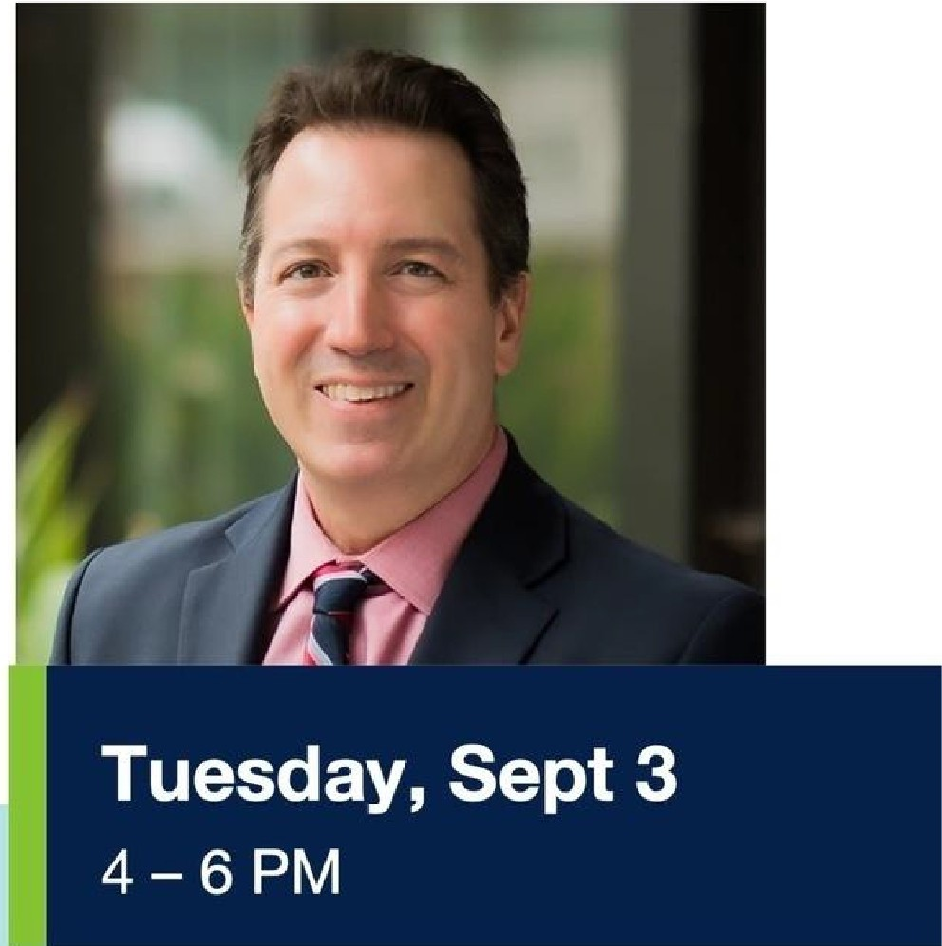
I r,..._ Department of ""� Surgery

Getting to Patients
with Alexander Fay, MD, PhD

Parnassus Campus, Health Sciences West Presentation: HSW-301 (4 - 5:30 PM) Reception: HSW Lobby (5:30 - 6 PM)

Gene Therapy for Duchenne Muscular Dystrophy

with a Patient Perspective
Dr. Alexander Fay, pediatric neurologist with special training in neuromuscular diseases, and his patient will discuss a Duchenne muscular dystrophy therapy, followed by Q&A session moderated by Dr. Julia Brown, Assistant Professor, UCSF Bioethics Program. Reception to follow.



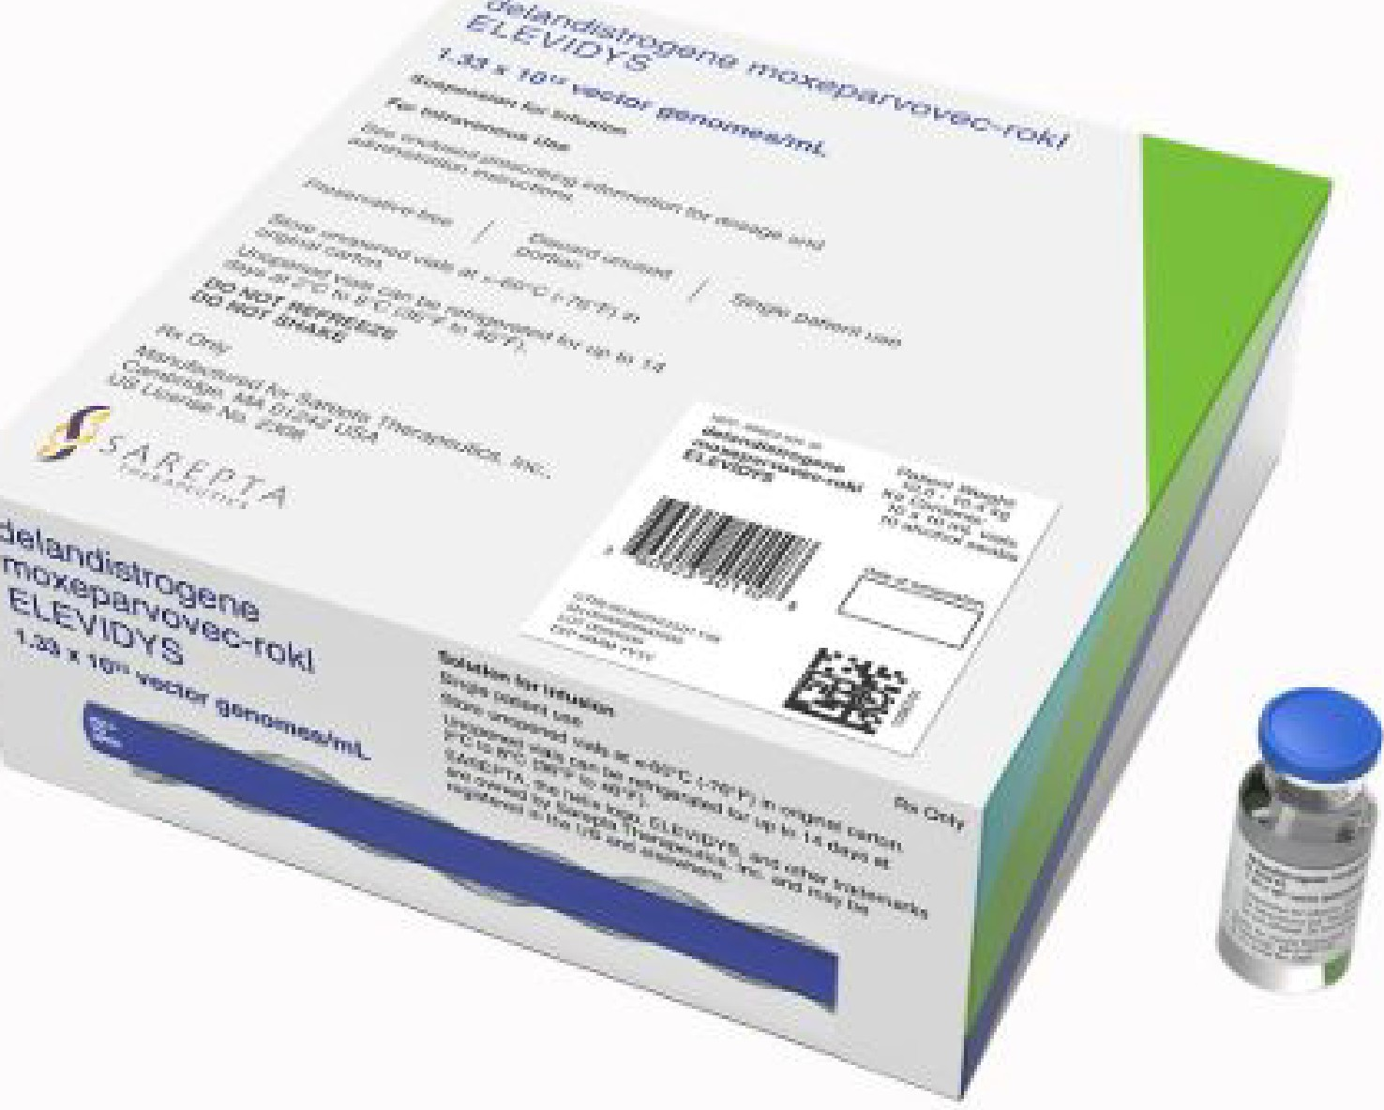
THE READOUT LOUD ALLISON DEANGELIS, ADAM FEUERSTEIN, AND ELAINE CHEN

Inside an FDA drug rejection, and layoffs at Sarepta


THE READOUT LOUD ADAM FEUERSTEIN, ELAINE CHEN, AND ALLISON DEANGELIS

A mother's perspective on Sarepta's gene therapy halt

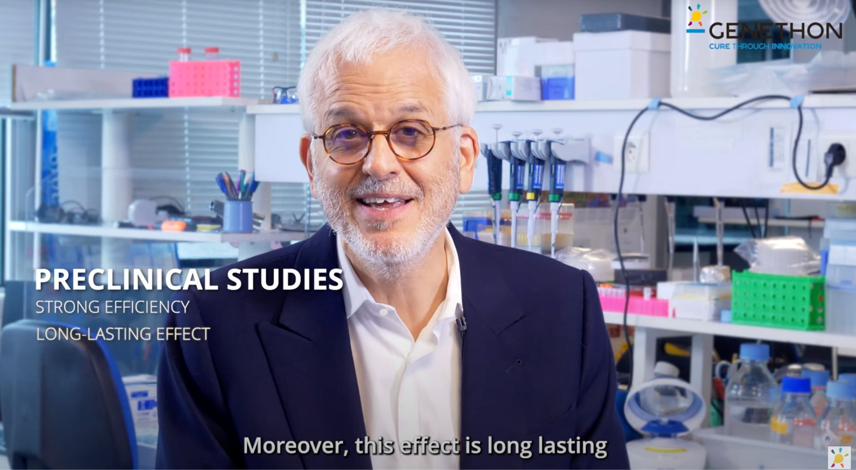

Summary
- Different animal models offer different things;
- Understand the model systems;
- Clarify your question and pick a model that would help you address the clinical need;
- Plan your experiments well.






References
Ezran, C. et al., 2017. The Mouse Lemur, a Genetic Model Organism for Primate Biology, Behavior, and Health. Genetics, 206(2), pp.651–664.

Ho, C.L.A., Fichtel, C. & Huber, D., 2021. The gray mouse lemur (Microcebus murinus) as a model for early primate brain evolution. Current opinion in neurobiology, 71, pp.92–99.
Kaufman, C.K. et al., 2016. A zebrafish melanoma model reveals emergence of neural crest identity during melanoma initiation. Science, 351(6272), p.aad2197.

Jónasdóttir, T.J. et al., 2000. Genetic mapping of a naturally occurring hereditary renal cancer syndrome in dogs. Proceedings of the National Academy of Sciences of the United States of America, 97(8), pp.4132–4137.
Loewa, A., Feng, J.J. & Hedtrich, S., 2023. Human disease models in drug development. Nature reviews bioengineering, pp.1–15.

McGreevy, J.W. et al., 2015. Animal models of Duchenne muscular dystrophy: from basic mechanisms to gene therapy. Disease models & mechanisms, 8(3), pp.195–213.
Ostrander, E.A., 2012. Both Ends of the Leash — The Human Links to Good Dogs with Bad Genes. The New England journal of medicine, 367(7), pp.636–646. Schoenebeck, J.J. et al., 2012. Variation of BMP3 contributes to dog breed skull diversity. PLoS genetics, 8(8), p.e1002849.
Vieira, N.M. et al., 2015. Jagged 1 Rescues the Duchenne Muscular Dystrophy Phenotype. Cell, 163(5), pp.1204–1213.
White, R.M. et al., 2008. Transparent adult zebrafish as a tool for in vivo transplantation analysis. Cell stem cell, 2(2), pp.183–189.
White, R., Rose, K. & Zon, L., 2013. Zebrafish cancer: the state of the art and the path forward. Nature reviews. Cancer, 13(9), pp.624–636.

Zucconi, E. et al., 2010. Ringo: discordance between the molecular and clinical manifestation in a golden retriever muscular dystrophy dog. Neuromuscular disorders: NMD, 20(1), pp.64–70.

